UniWRS (Workspace Reservation System)
SPROJ Report



Syed Meesum Raza Naqvi (24100183)

Advisor: Prof. Waqar Ahmad
School of Science and Engineering
Lahore University of Management Sciences
Submission Date

Acknowledgement and Dedication

I would like to express my deepest gratitude to my advisor, Prof. Waqar Ahmad, and my co-advisor, Sir Sohaib Ayub, for their continuous support and guidance throughout this journey. This project was part of my Senior Year Project, and completing it alone was an immense challenge since such projects are usually done in groups of five students. The workload was demanding, especially as I had to manage it alongside heavy courses like Operating Systems, Databases, and Computer Vision, as well as my father's deteriorating health. His kidney failure placed the responsibility of his treatment and care entirely on my shoulders, making this journey even more challenging.

Building the Workspace Reservation System web application required mastering key concepts, including the MERN stack and React Konva (HTML5 Canvas) for creating an interactive map-like layout of workspaces. The documentation process took just as much time and effort as the development itself. Despite the heavy workload and personal struggles, my advisors were flexible with deadlines and provided me with valuable feedback that helped me stay on track. I am incredibly proud to have completed a project of this magnitude alone in just one semester, following the vision and instructions of my advisor. This experience has been one of immense growth, and I dedicate this project to my mentors and everyone who supported me along the way, especially my family.

Certificate
I certify that the senior project titled “Workspace Reservation System” was completed under my supervision by the following students:

___________________________________________________________________
___________________________________________________________________
___________________________________________________________________

and the project deliverables meet the requirements of the program.

------------------------------------- Date:
Advisor (Signature)

------------------------------------- Date:
Co-advisor (if any)

Table of Contents

Introduction .................................................................................................................. 5

System Requirements .................................................................................................. 7

System Architecture ................................................................................................... 11

Requirements Specifications ..................................................................................... 15

Software Development Methodology and Plan ....................................................... 32

Database Design and Web Services .......................................................................... 35

System User Interface ................................................................................................ 40

Project Security .......................................................................................................... 50

Risk Management ...................................................................................................... 53

Testing and Evaluation ............................................................................................. 54

Deployment Guidelines ............................................................................................. 56

Conclusion .................................................................................................................. 59

Review Checklist ....................................................................................................... 60

References .................................................................................................................. 60

Introduction

Introduction

- Domain of the application:
The project falls under the domain of workspace management and reservation systems.
- Target users of this application:
Teaching Assistants (TAs) and Coordinators in university departments are the primary users.
- It’s a web application, developed using the MERN stack (MongoDB, Express.js, React.js, Node.js), which facilitates booking and managing workspaces.

Objective and Scope
Objectives:
- To simplify the booking process for university workspace management.
- To ensure seamless handling of multiple user roles with specific booking permissions.
- To maintain an organized system by automatically cleaning outdated reservations.
Why Chosen: Workspace booking often involves manual processes prone to errors and conflicts. This application provides an efficient, conflict-free, and automated solution.
Impact: Enhances operational efficiency by preventing double bookings, providing real-time updates, and saving administrative overhead.

Development Methodology
The project was developed using Agile (Scrum) methodology. Iterative sprints allowed incorporating feedback from supervisor and co-supervisor and fellow Tas for features like real-time availability and automated cleanup. The team, as a single developer, prioritized flexibility and iterative testing.

Contributions
Innovative Aspects:
- Real-time table availability with visual indicators (green for available, red for reserved).
- Automatic removal of outdated reservations to maintain database integrity.
- Role-based functionality for TAs and Coordinators.
Comparison:
- Unlike traditional systems, this application includes conflict prevention for double bookings, real-time updates, and customizable booking options.
- Integration of user-friendly UI ensures a smooth experience compared to legacy booking systems

System Requirements

System Actors
Actor Name | Description
Teaching Assistant (TA) | A user who can reserve up to two tables at a time. TAs can view their bookings, cancel reservations, and access FAQs for guidance.
Coordinator (Admin) | A user with advanced permissions to book multiple tables, manage reservations for all users, create FAQs, and handle user accounts.
System | The application itself, which enforces rules like preventing double bookings, deleting past reservations, and ensuring data consistency.

Functional Requirements

Functional Requirements
Sr# | Requirement
1 | As a Teaching Assistant (TA), I want to view all available workspaces so I can choose the best one for my needs.
2 | As a Teaching Assistant (TA), I want to filter available workspaces by date, time, and room to find the most convenient options.
3 | As a Teaching Assistant (TA), I want to reserve up to two tables at once to fit my limited needs.
4 | As a Teaching Assistant (TA), I want to view my bookings to stay informed about my reservations.
5 | As a Teaching Assistant (TA), I want to cancel my bookings if my plans change.
6
  As a Teaching Assistant (TA), I want access to FAQs for quick help with using the app.
7 | As a Coordinator (Admin), I want to book multiple tables for different users as needed.
8 | As a Coordinator (Admin), I want to view all users’ bookings to manage workspace utilization.
9 | As a Coordinator (Admin), I want to cancel bookings made by others if necessary.
10
  As a Coordinator (Admin), I want to add new users to ensure everyone can access the system.
11
  As a Coordinator (Admin), I want to delete user accounts if they are no longer needed.
12 | As a Coordinator (Admin), I want to create FAQs so that I can share updates or help information.
13 | As a Coordinator (Admin), I want to delete outdated FAQs to keep the information current.
14 | As a Coordinator (Admin), I want to search for users by their role to manage accounts efficiently.
15
  As a Coordinator (Admin), I want to update user details like names or emails to maintain accurate records.
16
  As a System, I want to automatically delete past reservations to keep the database clean and relevant.
17
  As a System, I want to prevent double bookings for the same table to ensure fairness.
18
  As a System, I want to show real-time updates for table availability so users can make informed decisions.
19
  As a System, I want to highlight reserved tables in red and available tables in green for better clarity.
20
  As a System, I want to ensure users are authenticated securely to protect their accounts and data.

Non-functional Requirements

Sr# | Requirements
1 | The system should load the dashboard within 3 seconds after login to ensure a smooth user experience.
2 | The system should be available for use more than 98% of the time to ensure reliability for users.
3 | The system should provide real-time updates for table availability with a delay of no more than 4 seconds.
4 | The system should use less than 1 GB of memory during normal operation.

System Architecture

This chapter provides an overview of the system's architecture, highlighting the design and structure that support its functionality. The system is divided into two main components: the frontend and the backend, each with clearly defined roles to ensure scalability, maintainability, and efficient operations. The frontend handles user interactions and workspace reservations, while the backend processes data and manages essential services like authentication, booking, and user management.
Additionally, the architecture demonstrates the interaction between components using web sockets and database queries, with MongoDB Atlas as the database and Render as the deployment platform. The architecture ensures a seamless experience for the target users by integrating multiple services to provide real-time workspace management and booking functionalities.

Architecture Diagram

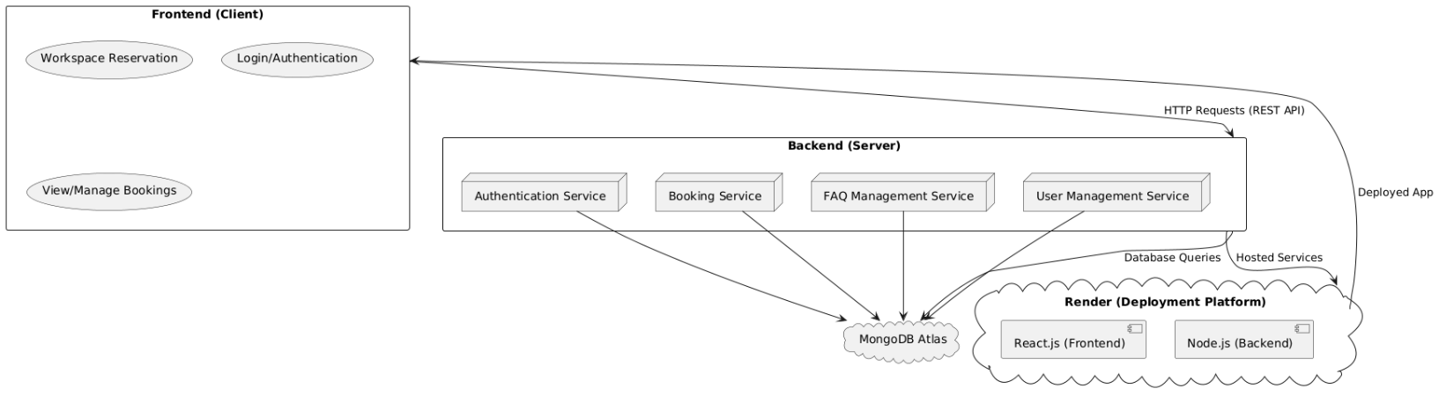

Architecture Description

Subsystem Descriptions:
- Frontend (Client):
  - Workspace Reservation: Allows users to search and reserve available workspaces by specifying room numbers, dates, and times.
  - Login/Authentication: Provides secure login functionality with authentication rules and allows users to update credentials.
  - View/Manage Bookings: Enables users to view their bookings, cancel reservations, and manage their profile details. Coordinators can view all users' bookings.
  - Interaction: Communicates with the backend via web sockets for data fetching and updates.

- Backend (Server):
  - Authentication Service: Handles user authentication, login credentials, and security measures like password hashing using bcrypt.
  - Booking Service: Manages workspace reservations, ensures no conflicts, and automatically deletes past reservations to maintain system efficiency.
  - FAQ Management Service: Allows Coordinators to add, update, or delete FAQs visible to all users, ensuring up-to-date information is displayed.
  - User Management Service: Handles user creation, deletion, and role management. Sends credentials to new users via email (locally supported; may require Render's paid tier for production email service).

- Database:
  - MongoDB Atlas: Stores user profiles, booking data, and FAQs in a scalable cloud-based environment. It efficiently handles CRUD operations and supports real-time queries.

- Deployment Platform:
  - Render: Hosts the application (frontend and backend) in a serverless environment. Provides automated scaling, RAM, and storage management. Ideal for handling variable user loads.

Interaction Between Subsystems:
- The Frontend sends user requests via HTTP and sockets to the Backend, which processes the data and interacts with MongoDB Atlas for data persistence.
- The Backend communicates with the deployment platform (Render) to serve the frontend and backend logic.
- FAQs, user bookings, and other dynamic data are fetched from the backend and displayed in real-time on the frontend.
- The database ensures consistency and prevents conflicts, while Render ensures seamless app hosting and scaling.

Justification of the Architecture
Pros:
- Scalability: The use of Render's serverless infrastructure and MongoDB Atlas ensures that the system can handle varying user loads.
- Separation of Concerns: The architecture clearly separates the frontend, backend, and database, enhancing maintainability.
- Flexibility: Modular design (Authentication, Booking, FAQ, User Management) allows independent updates to services.
- Ease of Deployment: Render simplifies the deployment process, managing server and hosting requirements.
- Real-time Updates: The web sockets structure enables fast and efficient communication between client and server.
- Security: Implements best practices such as bcrypt for password hashing and role-based access control.
Cons:
- Dependency on Third-Party Services: Reliance on Render and MongoDB Atlas may incur costs for premium features like email services and higher storage.
- Latency: Free-tier hosting may result in slower performance during high loads.

Justification:
This architecture is suitable for the project due to its alignment with the system’s requirements, including scalability, modularity, and real-time updates. By separating concerns into distinct subsystems, the architecture facilitates smooth communication and efficient management of tasks.
Additionally, the architecture addresses non-functional requirements like:
- Reliability: Automatic deletion of past bookings ensures efficient database management.
- Performance: Render provides a robust environment for scaling with workload, while MongoDB Atlas ensures fast query execution.
- Usability: Clean interaction flow between frontend and backend simplifies the user experience.

Tools and Technologies
- Front-End: React.js (v18.0)
- Back-End: Node.js (v16), Express (v4.x)
- Database: MongoDB Atlas
- Notification System: NodeMailer for email notifications
- Testing: Selenium for UI testing
- Development IDE: Visual Studio Code
- Deployment Platform: Render for hosting
- Version Control: Git (GitHub repository)

Requirements Specifications
The Requirements Specification chapter outlines the core functional and non-functional requirements of the Workspace Reservation System. It defines the system's use cases, including diagrams and detailed descriptions of user interactions and system behaviours. The section ensures clarity on how the system meets user needs, focusing on functionality like workspace booking, user management, and automated tasks. It also includes UML diagrams and detailed descriptions of classes, use cases, and their associated workflows. This chapter forms the foundation for system design and implementation, ensuring all requirements are comprehensively addressed.

Use Cases
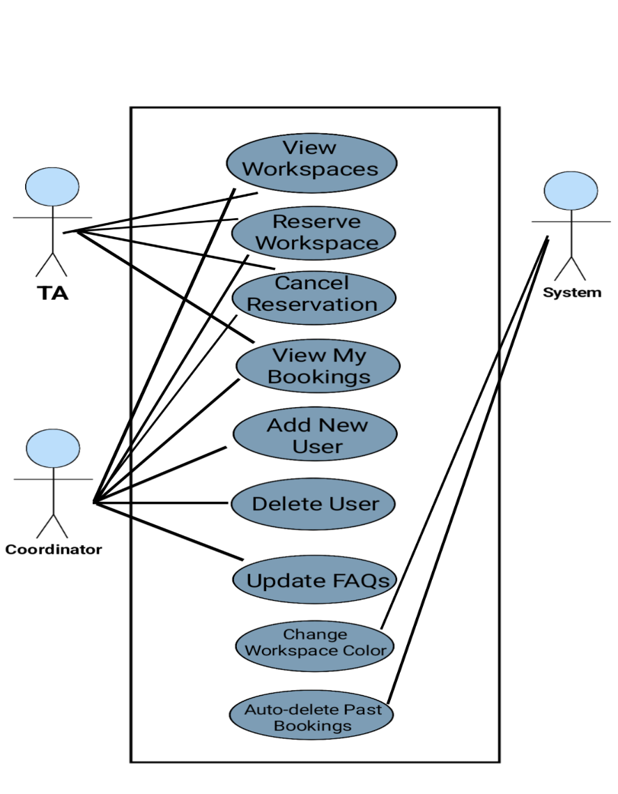

View Available Workspaces
Identifier |  | UC-001
Purpose |  | Allow users to see all workspaces whether available or not.
Pre-conditions |  | User must be logged into the system.
Post-conditions |  | System displays a list of workspaces based on the user's criteria.
Step # | Typical Course of Action
 | User logs into the system.
 | User navigates to the 'Book Workspaces' page and see all workspaces there.
 | User searches based on criteria (date, time, room).
 | User inputs the criteria.
 | System displays workspaces accordingly.
Step # | Alternate Courses of Action
 | If the user does not select criteria, all available and unavailable workspaces of the next time slot are shown.
Step # | Exception Paths
 | User is not logged in, and the system redirects them to the login page.

Reserve a Workspace
Identifier |  | UC-002
Purpose |  | Enable users to reserve a workspace based on availability.
Pre-conditions |  | User must be logged in and workspace should be available.
Post-conditions |  | Workspace is reserved and marked as unavailable.
Step # | Typical Course of Action
 | User logs in and navigates to the 'Book WorkSpaces' page.
 | User selects an available workspace from the displayed list.
  User clicks 'Yes’ to confirm the booking.
 | System verifies the availability of the workspace.
 | System validates the reservation and updates the availability status.
Step # | Alternate Courses of Action
 | If the selected workspace is already reserved, the system displays “Already booked”.
Step # | Exception Paths
 | If the system fails to update the reservation, an error message is displayed.

Cancel a Reservation
Identifier |  | UC-003
Purpose |  | Allow users to cancel an existing reservation.
Pre-conditions |  | User must have an existing reservation.
Post-conditions |  | Reservation is canceled and marked as available.
Step # | Typical Course of Action
 | User navigates to 'View My Bookings'.
 | User selects a reservation and clicks 'Cancel'.
 | User selects the reservation to cancel.
 | System confirms the cancellation and updates availability.
 | System prompts “Booking cancelled successfully”.
Step # | Exception Paths
 | If the cancellation request fails, the system displays an error message.

View My Bookings
Identifier |  | UC-004
Purpose
  Allow users to view their current and upcoming reservations.
Pre-conditions |  | User must be logged in and have active reservations.
Post-conditions |  | User sees a list of their active reservations.
Step # | Typical Course of Action
  User logs in and navigates to the 'View My Bookings' page.
 | System fetches and displays the user’s reservations.
  User reviews the list of bookings.
Step # | Alternate Courses of Action
 | If no active reservations exist, the system displays a message: “No bookings found.”

Search Workspaces
Identifier |  | UC-005
Purpose
  Allow users to search for workspaces based on specific criteria.
Pre-conditions |  | User must be logged in.
Post-conditions
  Search results are displayed based on the criteria.
Step # | Typical Course of Action
 | User logs in and navigates to the 'Book WorkSpaces' page
 | User enters search criteria such as date, time, and room number.
 | User clicks 'Search'.
 | System filters and displays the matching results.
Step # | Alternate Courses of Action
 | If the user does not select criteria, all available and unavailable workspaces of the next time slot are shown.

Prevent Double Booking
Identifier |  | UC-006
Purpose |  | Ensure no two users can book the same workspace at the same time.
Pre-conditions
  User or Admin must attempt to book a workspace.
Post-conditions |  | Booking conflicts are avoided, and availability is updated.
Step # | Typical Course of Action
 | User selects a workspace and initiates a reservation.
 | System checks the workspace availability.
 | If available, the system confirms the booking.
Step # | Alternate Courses of Action
 | If the workspace is already booked, the system displays: “Already booked”
Step # | Exception Paths
 | If the availability check fails, the system shows an error message.

Real-time Updates for Availability
Identifier |  | UC-007
Purpose |  | Provide users with real-time updates on workspace availability.
Pre-conditions |  | System must be operational and synchronized with the database.
Post-conditions |  | Workspace availability is updated dynamically.
Step # | Typical Course of Action
 | User navigates to the 'Book Workspaces' page.
  System fetches and updates workspace statuses in real time.
Step # | Alternate Courses of Action
 | If real-time updates fail, the system displays cached data and a warning.
Step # | Exception Paths
 | If the connection to the database fails, the system notifies the user.

Auto-delete Past Reservations
Identifier |  | UC-008
Purpose |  | Automatically remove expired bookings to maintain a clean database.
Pre-conditions |  | System must run a conditioned cleanup process.
Post-conditions |  | Expired bookings are removed from the database.
Step # | Typical Course of Action
  System checks for bookings with past dates.
 | System removes expired reservations.
Step # | Alternate Courses of Action
 | If no past bookings are found, the system completes the process without action.

Authenticate User
Identifier |  | UC-009
Purpose |  | Ensure only valid users can access the system.
Pre-conditions
  User must provide valid credentials.
Post-conditions |  | User gains access to the system.
Step # | Typical Course of Action
  User enters email and password on the login page.
 | System validates credentials.
  User is redirected to the dashboard if authentication is successful.
Step # | Alternate Courses of Action
 | If credentials are invalid, the system displays an error message.

Change Workspace Color Based on Booking Status
Identifier |  | UC-010
Purpose |  | Update workspace color to reflect booking status (reserved or available).
Pre-conditions |  | User must confirm or cancel a booking.
Post-conditions |  | Workspace color changes to red (reserved) or green (available).
Step # | Typical Course of Action
 | User reserves a workspace by completing the booking process.
 | System updates the workspace status in the database.
 | Workspace color changes to red, indicating it is reserved.
 | If the user cancels the booking, the system updates the status.
 | Workspace color changes back to green, indicating it is available.

Class Diagram

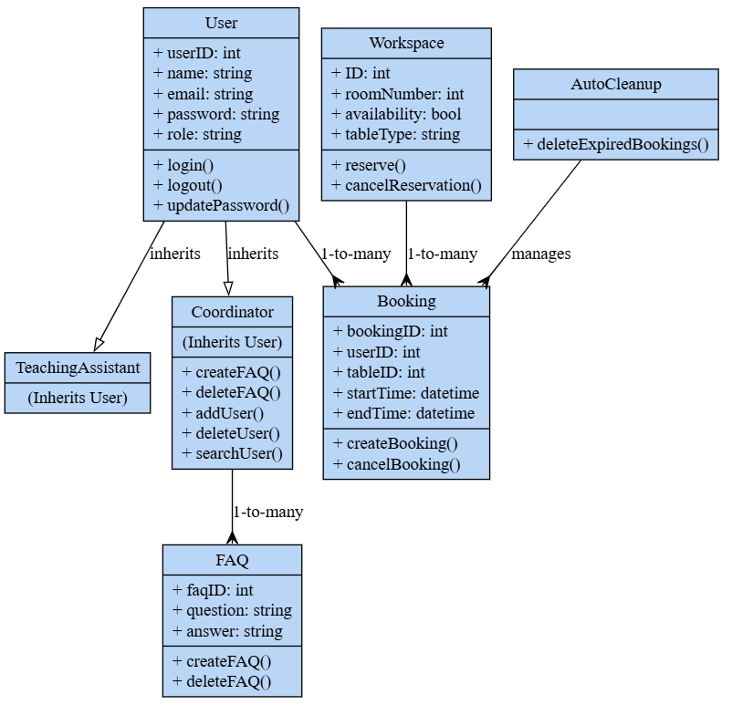
Classes and Descriptions
- User
Description: Represents the base class for all users in the system, including both Teaching Assistants and Coordinators. Provides common attributes and functionalities for managing user authentication and profile updates.
Attributes:
  - userID: Unique identifier for the user.
  - name: Name of the user (including First and Last Name).
  - email: User's email address for login and communication.
  - password: Encrypted password for secure authentication.
  - role: Role of the user (e.g., TA or Coordinator).
Operations:
  - login(): Authenticates the user and grants access to the system.
  - logout(): Logs the user out of the system.
  - updatePassword(): Updates the user's password based on provided input.

- TeachingAssistant
Description: Inherits from the User class. Represents a Teaching Assistant with permissions to view, reserve, and cancel bookings for workspaces.
Purpose: Focuses on workspace usage functionalities for Teaching Assistants.
Attributes and Operations: Inherits all from User.

- Coordinator
Description: Inherits from the User class. Represents a Coordinator (Admin) with administrative permissions, including managing users, FAQs, and workspace bookings.
Attributes and Operations:
  - Inherits all attributes from User.
  - Additional Operations:
    - createFAQ(): Adds a new FAQ entry.
    - deleteFAQ(): Removes an FAQ from the system.
    - addUser(): Adds a new user to the system.
    - deleteUser(): Deletes an existing user account.
    - searchUser(): Searches for a user in the system.

- Workspace
Description: Represents a workspace or table within a room. Tracks availability and allows reservation or cancellation of bookings.
Attributes:
  - ID: Unique identifier for the workspace.
  - roomNumber: The room in which the workspace is located.
  - availability: Indicates if the workspace is available (true/false).
  - tableType: Type of table (e.g., 1-seater, 2-seater).
Operations:
  - reserve(): Reserves the workspace for a booking.
  - cancelReservation(): Cancels the workspace reservation.

- Booking
Description: Tracks reservations made by users. Stores details like the booked workspace, timing, and the user who made the reservation.
Attributes:
  - bookingID: Unique identifier for the booking.
  - userID: Identifier of the user who made the booking.
  - tableID: Identifier of the reserved workspace.
  - startTime: Start time of the reservation.
  - endTime: End time of the reservation.
Operations:
  - createBooking(): Creates a new reservation in the system.
  - cancelBooking(): Cancels an existing reservation.

- FAQ
Description: Stores frequently asked questions and answers visible to users. Managed by Coordinators.
Attributes:
  - faqID: Unique identifier for the FAQ entry.
  - question: Text of the FAQ question.
  - answer: Text of the FAQ answer.
Operations:
  - createFAQ(): Adds a new FAQ to the system.
  - deleteFAQ(): Deletes an FAQ.

- AutoCleanup
Description: Manages system automation to maintain database integrity by removing outdated bookings.
Attributes:
  - No specific attributes as its purpose is functional.
Operations:
  - deleteExpiredBookings(): Automatically deletes bookings that are no longer valid.

Sequence Diagrams

Use case Name: View Available Workspaces

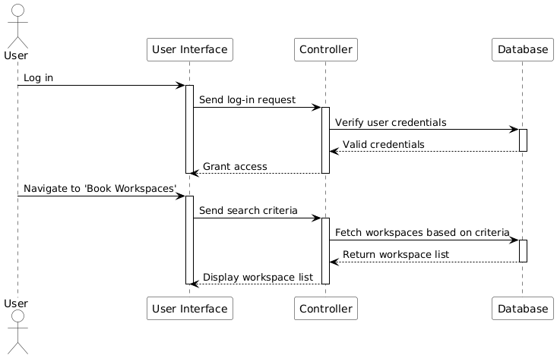

Use case Name: Reserve a Workspace

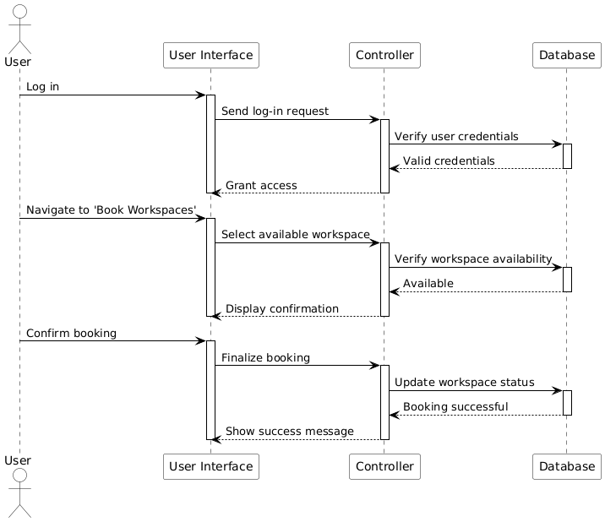

Use case Name: Cancel a Reservation

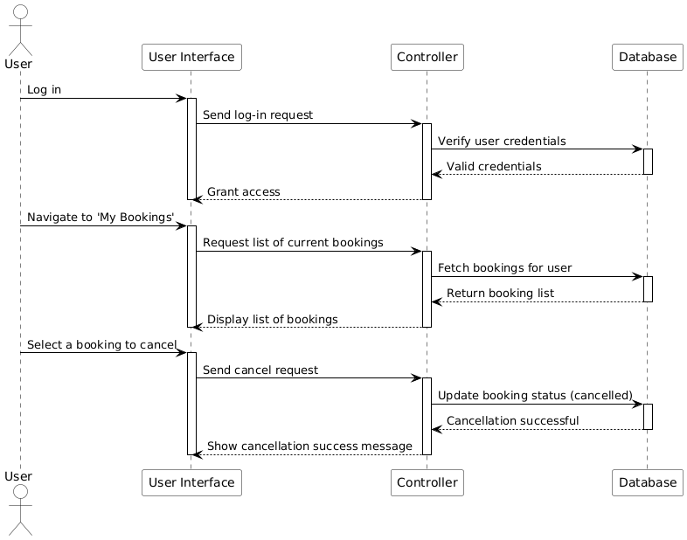

Use case Name: View My Bookings

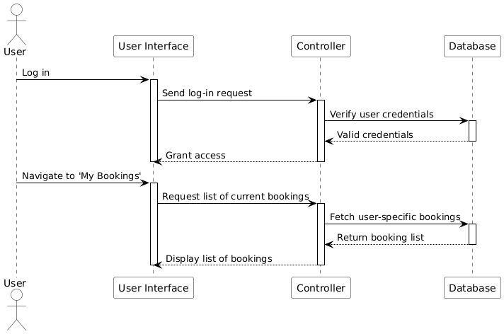

Use case Name: Search Workspaces

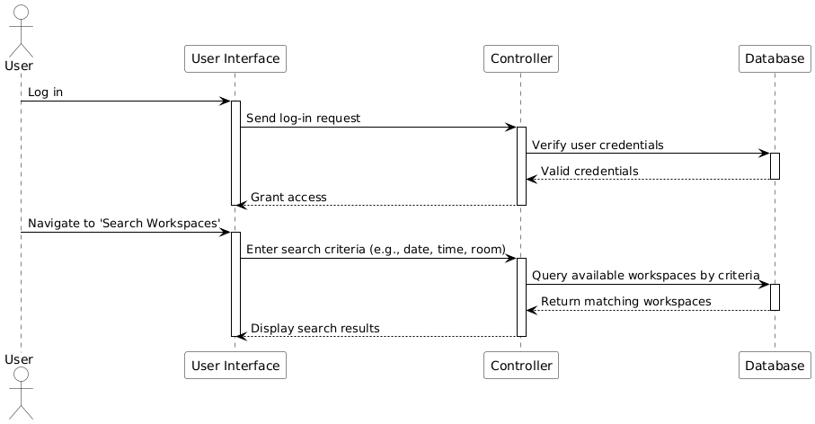

Use case Name: Authenticate User

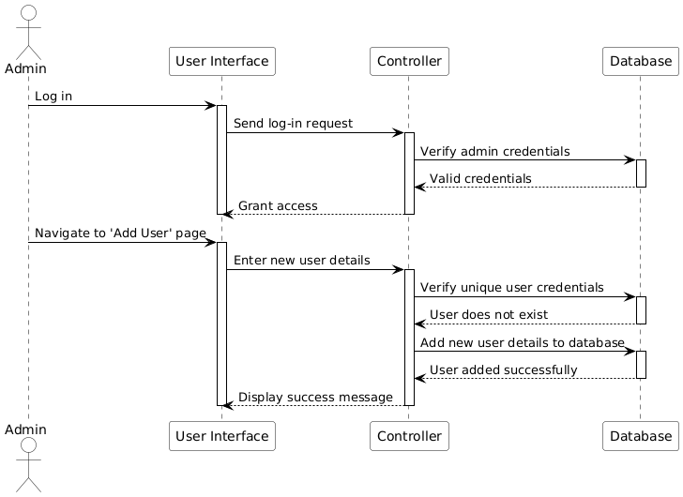

Use case Name: Prevent Double Booking

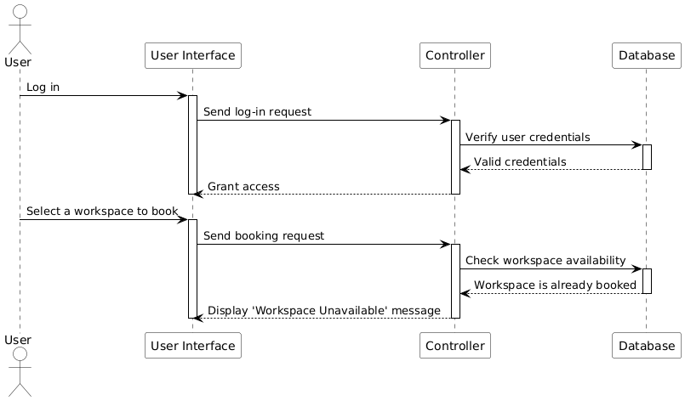

Use case Name: Real-time Updates for Availability

Use case Name: Auto-delete Past Reservations

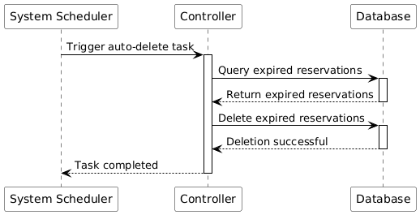

Use case Name: Display FAQs

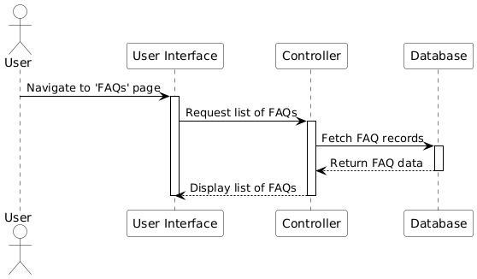

Use case Name: Change Workspace Color Based on Booking Status

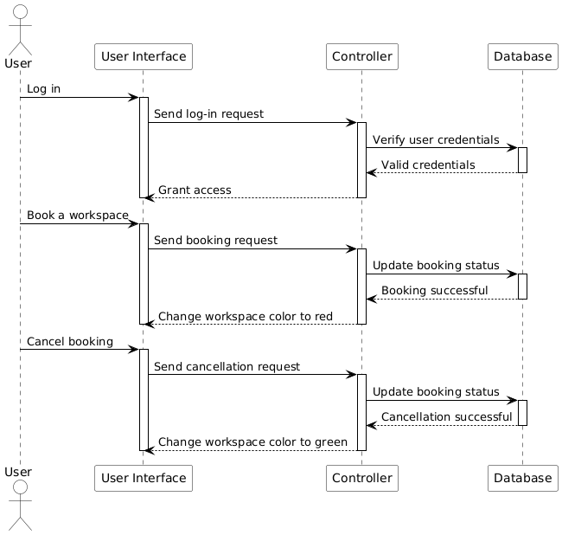

Software Development Methodology and Plan
The Software Development Methodology and Plan chapter outlines the process and approach used for developing the Workspace Reservation System. It discusses the selection of the software development methodology, comparing the pros and cons of Waterfall and Agile (Scrum) models, and justifies the chosen process. Additionally, this section provides a Gantt chart that visualizes the project timeline, detailing tasks, durations, milestones, and team member contributions to ensure a clear and organized project plan.

Software Process Selection

- Pros and Cons of Waterfall and Agile (Scrum) Processes
Waterfall Process:
- Pros:
  - Clear structure: Waterfall follows a linear, sequential approach. Each phase must be completed before moving to the next, making it easy to understand and manage.
  - Well-defined requirements: Waterfall works well when the requirements are stable and unlikely to change.
  - Emphasis on documentation: Every stage produces detailed documentation, making it easier to track progress and changes.
  - Good for large teams: It’s suitable for larger teams that need to work on different phases simultaneously but sequentially.
- Cons:
  - Rigid and inflexible: Once a phase is completed, it is hard to go back and make changes. This makes it unsuitable for projects where requirements may evolve.
  - Late delivery of the working system: A working product is not seen until late in the project lifecycle, meaning issues may be discovered late in development.
  - Risk of misunderstanding requirements: Since requirements are defined at the start and cannot change easily, any miscommunication can cause significant problems later.

Agile (Scrum) Process:
- Pros:
  - Flexibility: Agile allows for iterative development, which is especially beneficial when requirements are expected to change frequently.
  - Customer collaboration: Frequent communication and feedback from the customer ensures that the development team is always aligned with the client’s needs.
  - Early delivery of working software: Agile focuses on delivering small, functional parts of the software early, allowing testing and feedback throughout the project lifecycle.
  - Adaptive: Teams can easily adapt to changes, even late in development.
- Cons:
  - Less documentation: Agile tends to prioritize working software over documentation, which can be an issue if detailed documentation is needed later.
  - Requires skilled team: Agile relies heavily on team communication and collaboration. Without skilled team members, this could lead to mismanagement.
  - Potential for scope creep: Frequent changes and feedback can lead to the project’s scope expanding without proper control.

- Selected Process: Agile (Scrum)

For the development of the University Workspace Reservation System, the Agile (Scrum) methodology is selected. The project needs flexibility, adaptability, and continuous feedback from users such as faculty members, teaching assistants (TAs), and senior students, which Agile is well-suited to handle.

(3) Justification for the Selection:
For the Workspace Reservation System, Agile is more suitable because:
- Dynamic Search and Reservation Features: The system requires implementing dynamic search functionality and ensuring smooth reservation updates. Agile allows incremental development and testing of these features.
- Role-Based Functionality: The system has two user roles (TAs and Coordinators) with different booking permissions. Agile’s flexibility ensures these requirements are addressed iteratively.
- Frequent Testing: Features like preventing double booking and managing booking conflicts require constant testing to maintain system integrity. Agile’s iterative cycles align well with this.
- Room for Future Updates: Agile allows adaptability for potential enhancements, like integrating a notification system or expanding search criteria based on user feedback.
In a solo development scenario, Agile enables better task management, regular progress evaluation, and ensures the complex, interdependent requirements are met efficiently.

Gantt Chart

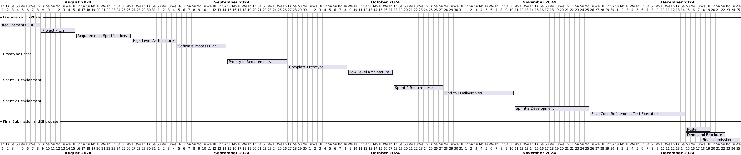
All tasks are done by Syed Meesum Raza.

Database Design and Web Services
The Database Design and Web Services chapter presents the structure and organization of the database for the Workspace Reservation System. It includes the entity-relationship (E/R) diagram, providing a detailed description of the entities, relationships, and data fields to ensure clarity in data management. Additionally, this section outlines the external APIs used in the project, specifying their purpose and integration to enhance the system's functionality and interoperability.

Database Design

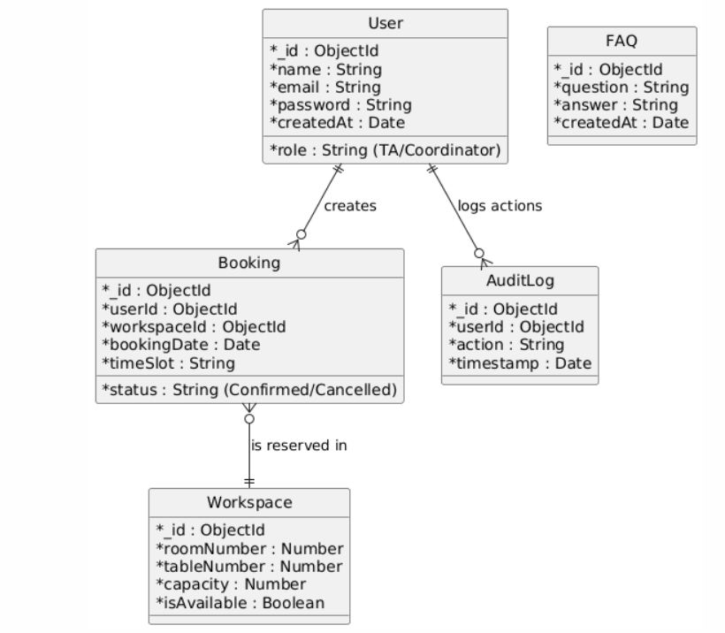

1. User
- Description: Represents the users of the system, which include Teaching Assistants (TAs) and Coordinators. Each user has attributes for authentication and role-based access.
- Attributes:
  - _id: Unique identifier for the user.
  - name: Full name of the user.
  - email: User's email address used for login.
  - password: Encrypted password for authentication.
  - createdAt: Date of account creation.
  - role: Specifies the user type (TA or Coordinator).
2. Workspace
- Description: Represents the available workspaces in the system, including rooms and tables. Each workspace has attributes related to its physical properties and availability.
- Attributes:
  - _id: Unique identifier for the workspace.
  - roomNumber: Number of the room where the workspace is located.
  - tableNumber: Specific table number within the room.
  - capacity: Number of seats available at the workspace.
  - isAvailable: Boolean indicating whether the workspace is available for reservation.
3. Booking
- Description: Captures reservation details for workspaces, linking users to specific workspaces for a given time slot and date.
- Attributes:
  - _id: Unique identifier for the booking.
  - userId: Identifier of the user who made the booking.
  - workspaceId: Identifier of the reserved workspace.
  - bookingDate: Date of the booking.
  - timeSlot: Time slot for which the booking is made.
  - status: Status of the booking (e.g., Confirmed or Cancelled).
4. FAQ
- Description: Stores frequently asked questions and their answers to assist users with system functionality.
- Attributes:
  - _id: Unique identifier for the FAQ entry.
  - question: The FAQ question text.
  - answer: Answer to the FAQ question.
  - createdAt: Date when the FAQ entry was created.
5. AuditLog
- Description: Logs user actions to maintain an activity trail for administrative and troubleshooting purposes.
- Attributes:
  - _id: Unique identifier for the audit entry.
  - userId: Identifier of the user who performed the action.
  - action: Description of the performed action.
  - timestamp: Date and time of the action.
This data model effectively captures the relationships and data requirements for the workspace reservation system, ensuring efficient management of users, reservations, and workspace availability.

API Specification

External APIs/Services
- Socket.io
  - Enables real-time, bidirectional communication between the server and client for updates related to workspace reservations.
- Axios
  - Used for making HTTP requests to backend API hosted on workspacereservation-backend.onrender.com.
- Nodemailer
  - Used on the server side to send emails (about user credentials while signing up).
- jsonwebtoken (JWT)
  - Used for handling user authentication and generating secure tokens for API requests.
- Mongoose
  - Interfaces with MongoDB, the database used to store user, workspace, and booking information.
- Moment.js
  - A library for handling date and time formatting and calculations.
- React Konva
  - Renders interactive workspace layouts on the client using HTML5 Canvas.
- React DatePicker
  - Provides a calendar UI for users to select booking dates.
Justification for External APIs
- These APIs/libraries serve different roles in the system:
  - Real-time updates with Socket.io.
  - Simplified HTTP requests with Axios.
  - Authentication via secure tokens with jsonwebtoken.
  - Date and time operations with Moment.js.
  - Database interactions using Mongoose.

System User Interface
This chapter introduces the System User Interface, focusing on how the application interacts with end users. It explains the key functionalities offered by the application, such as workspace reservation, viewing bookings, and managing user actions. The section also includes visual screenshots to provide a clear representation of the interface, showcasing navigation, forms, and user-friendly features designed to enhance usability and efficiency for the target audience.

Features
- User Authentication:
  - Users and admins can log in with their respective credentials.
  - Admin and TA roles are separated, each having access to different functionalities.
  - Passwords are securely stored in the database.
  - Prompts for Incorrect email, Incorrect password.
  - Logout Functionality within Web App. You can log out at any time.
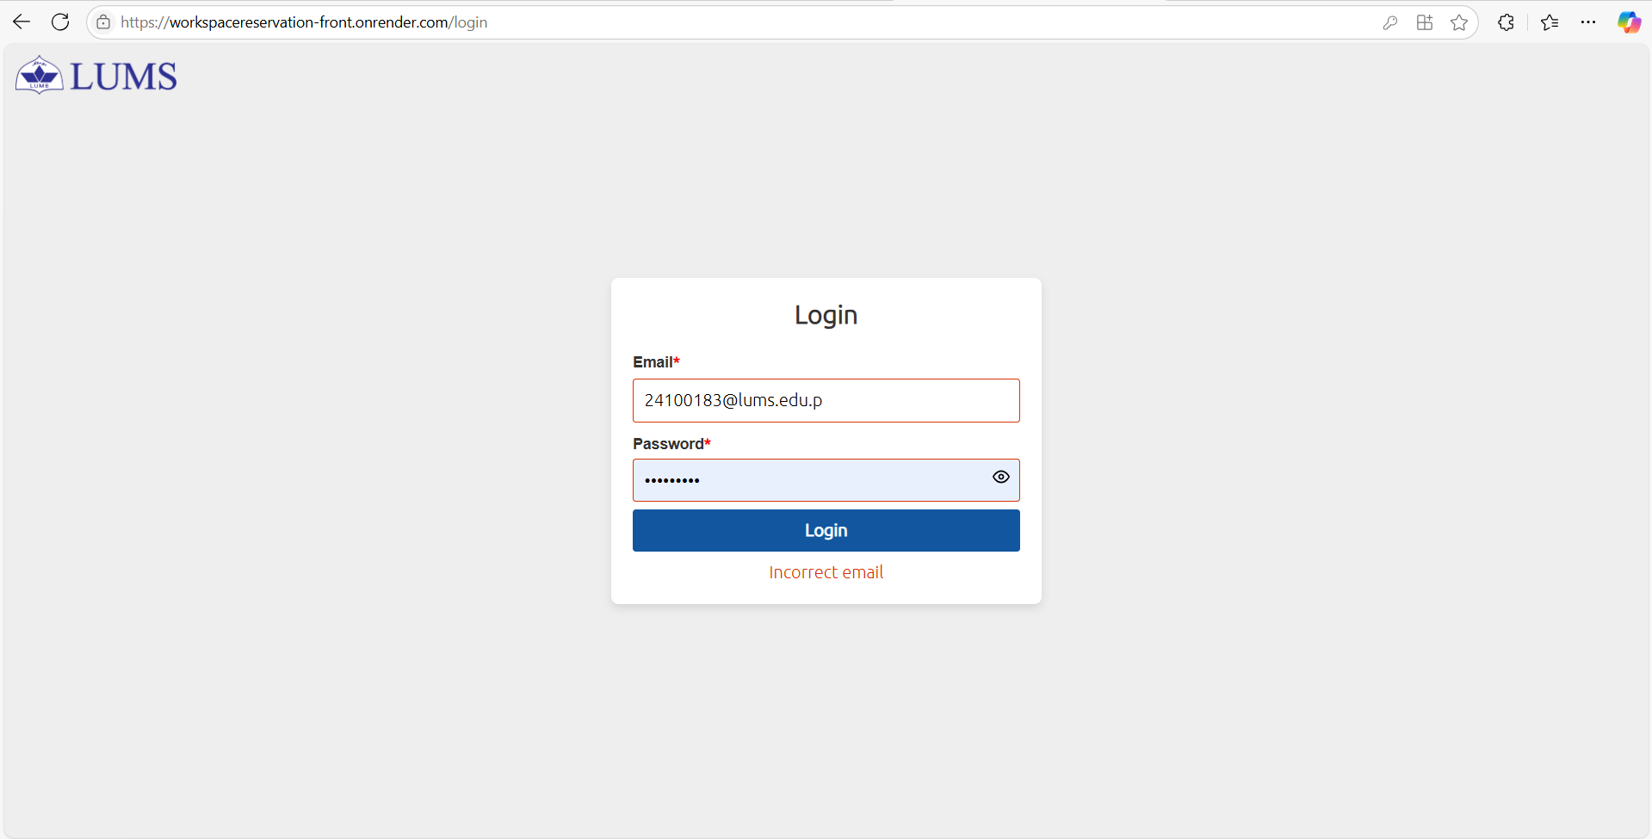

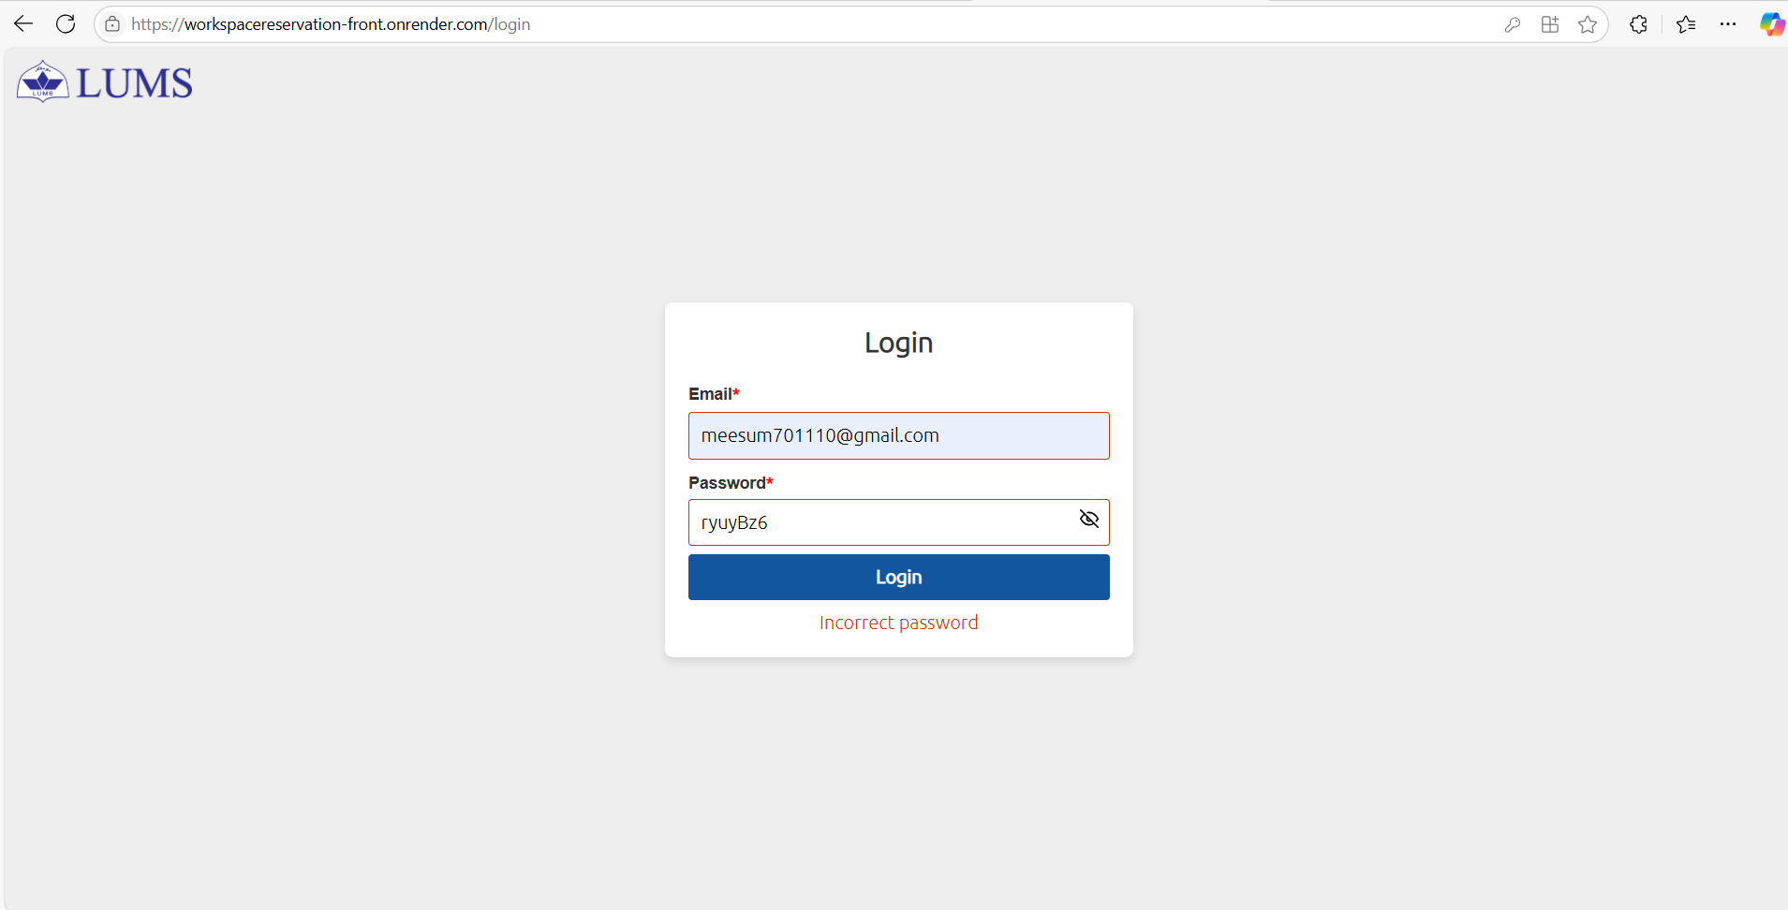

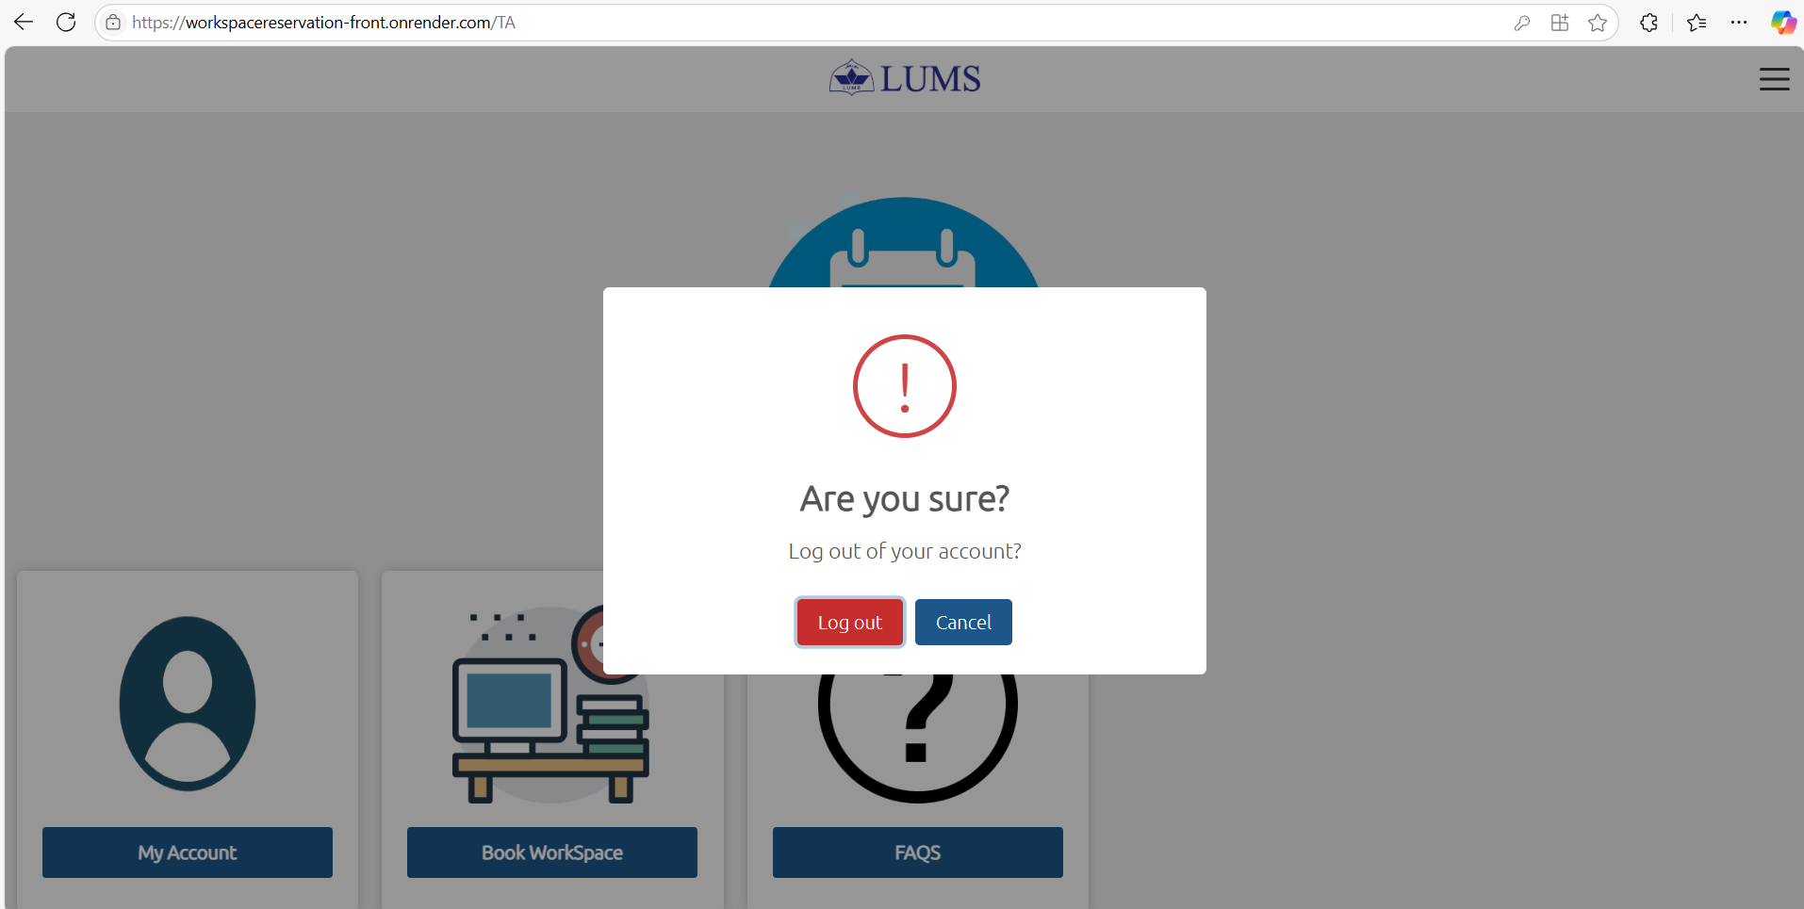

- Admin/Coordinator Dashboard:
  - Admins can view all booked and available workspaces, reserve, or cancel reservations of any user including himself.
  - Admins can view My Account, a list of all users (user records) and search by user role.
  - Admins can manage user records, including adding or deleting accounts.
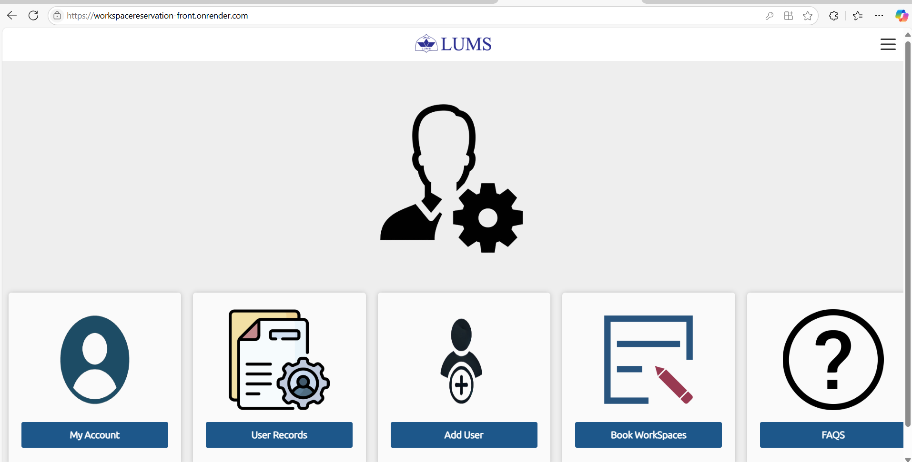

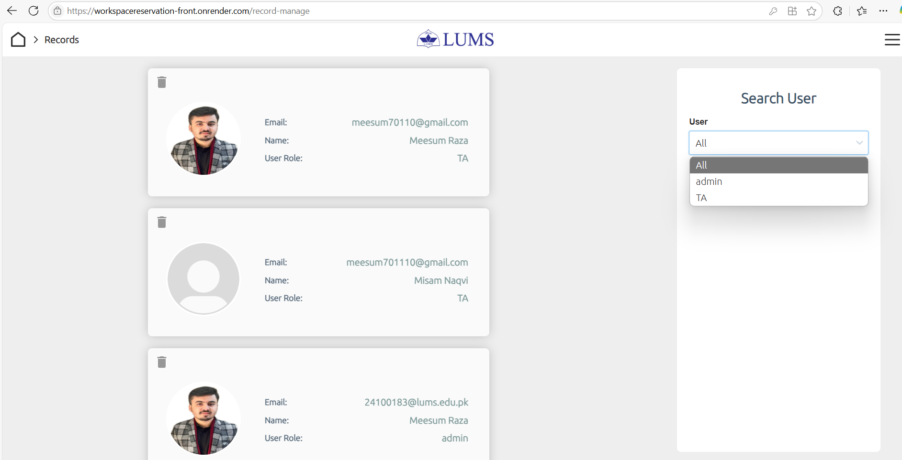

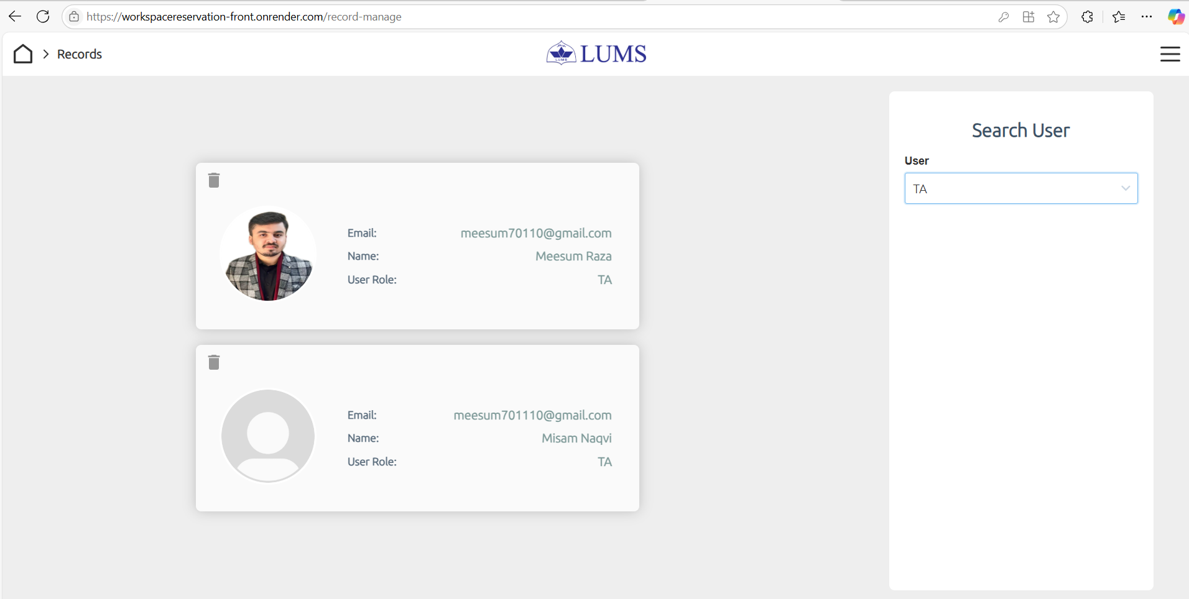

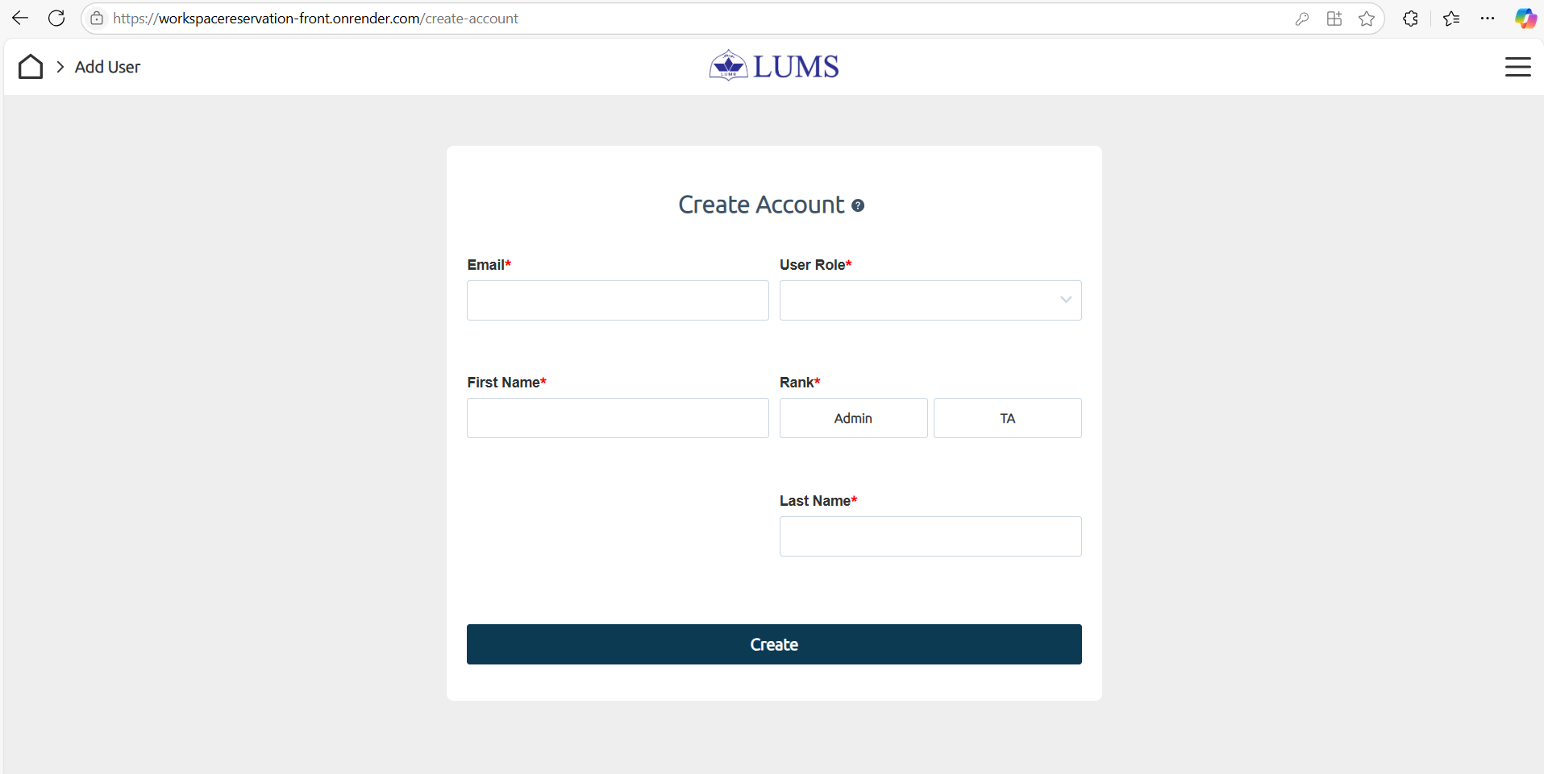

- TA Dashboard:
- User (TA) can Login with user credentials.
- View, and search for available workspaces, reserve, or cancel reservations.
- Access FAQs for help regarding the application.

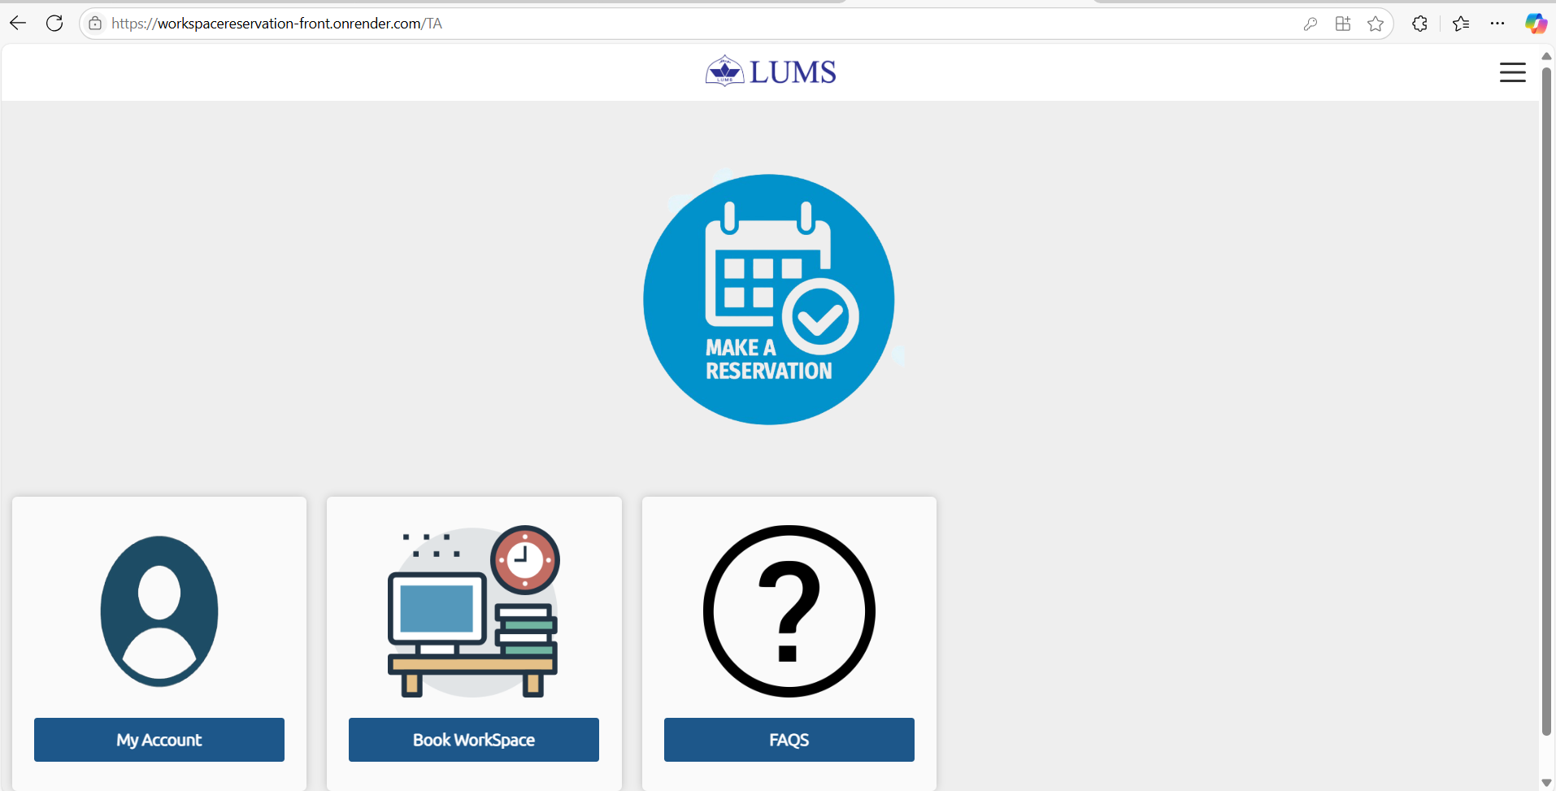

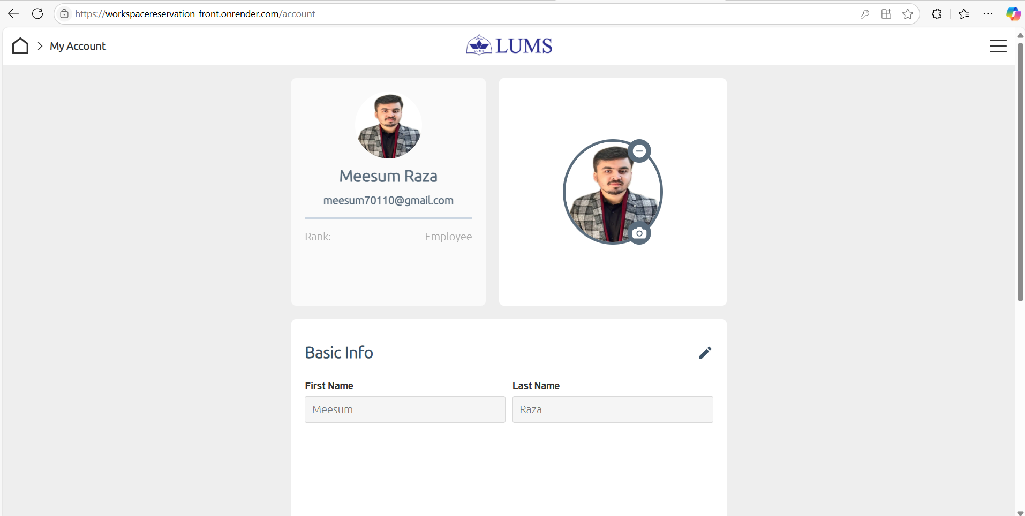

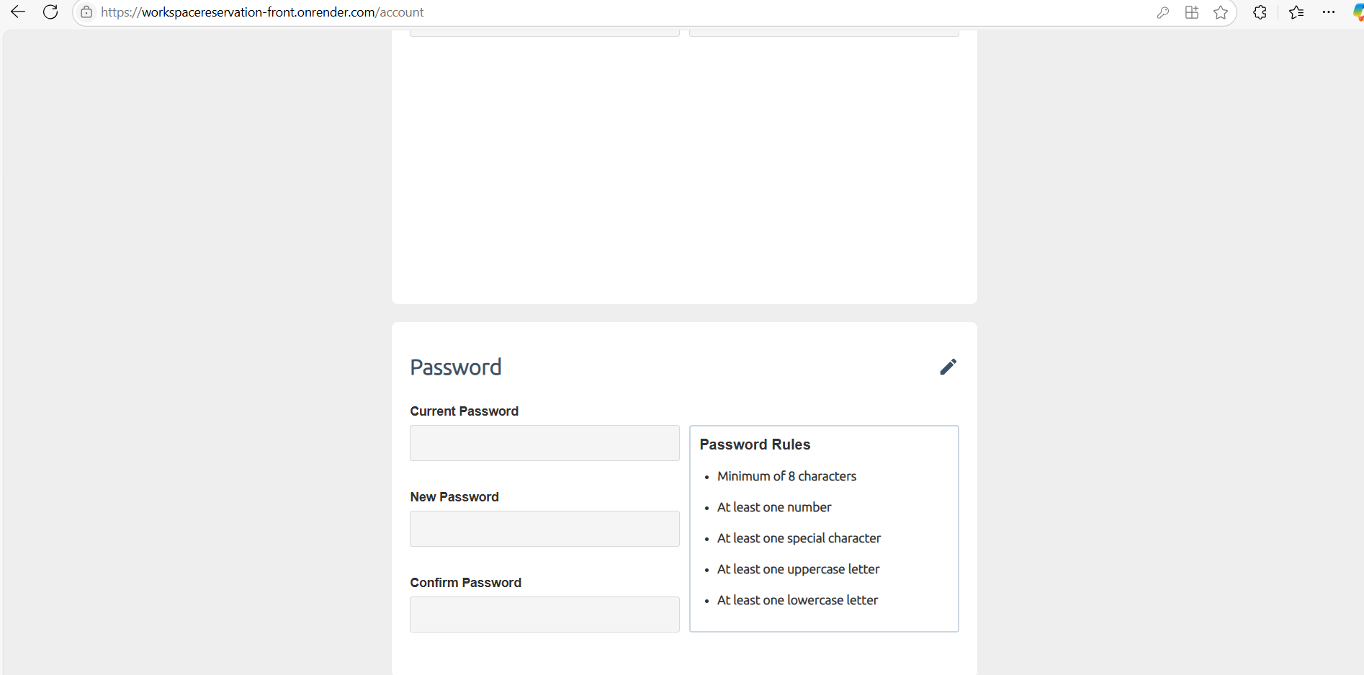

- Workspace Reservation:
  - 4 Rooms: Each room has 26 workspaces in different sizes (1, 2, 4, or 6-seater).
Two User Roles:
  - TAs: Can reserve up to 2 tables.
  - Coordinators: Can reserve multiple tables and manage others’ bookings.
Booking Management:
  - Users can view and cancel their own bookings.
  - Coordinators can manage both their own and others’ bookings.
  - Booking Availability: Reservations are available for the next 7 days.
  - Automatic Deletion: Past reservations are automatically deleted.
  - Search Functionality: Search by date, time, and room number.
  - Table Availability Indication: Reserved tables turn light red; available tables stay green.
  - Conflict Prevention: No double bookings for the same table at the same time..
  - Time: automatically sets to next hour from current time. If it’s above 5pm, then it automatically sets to 9am slot next day in the search bar.

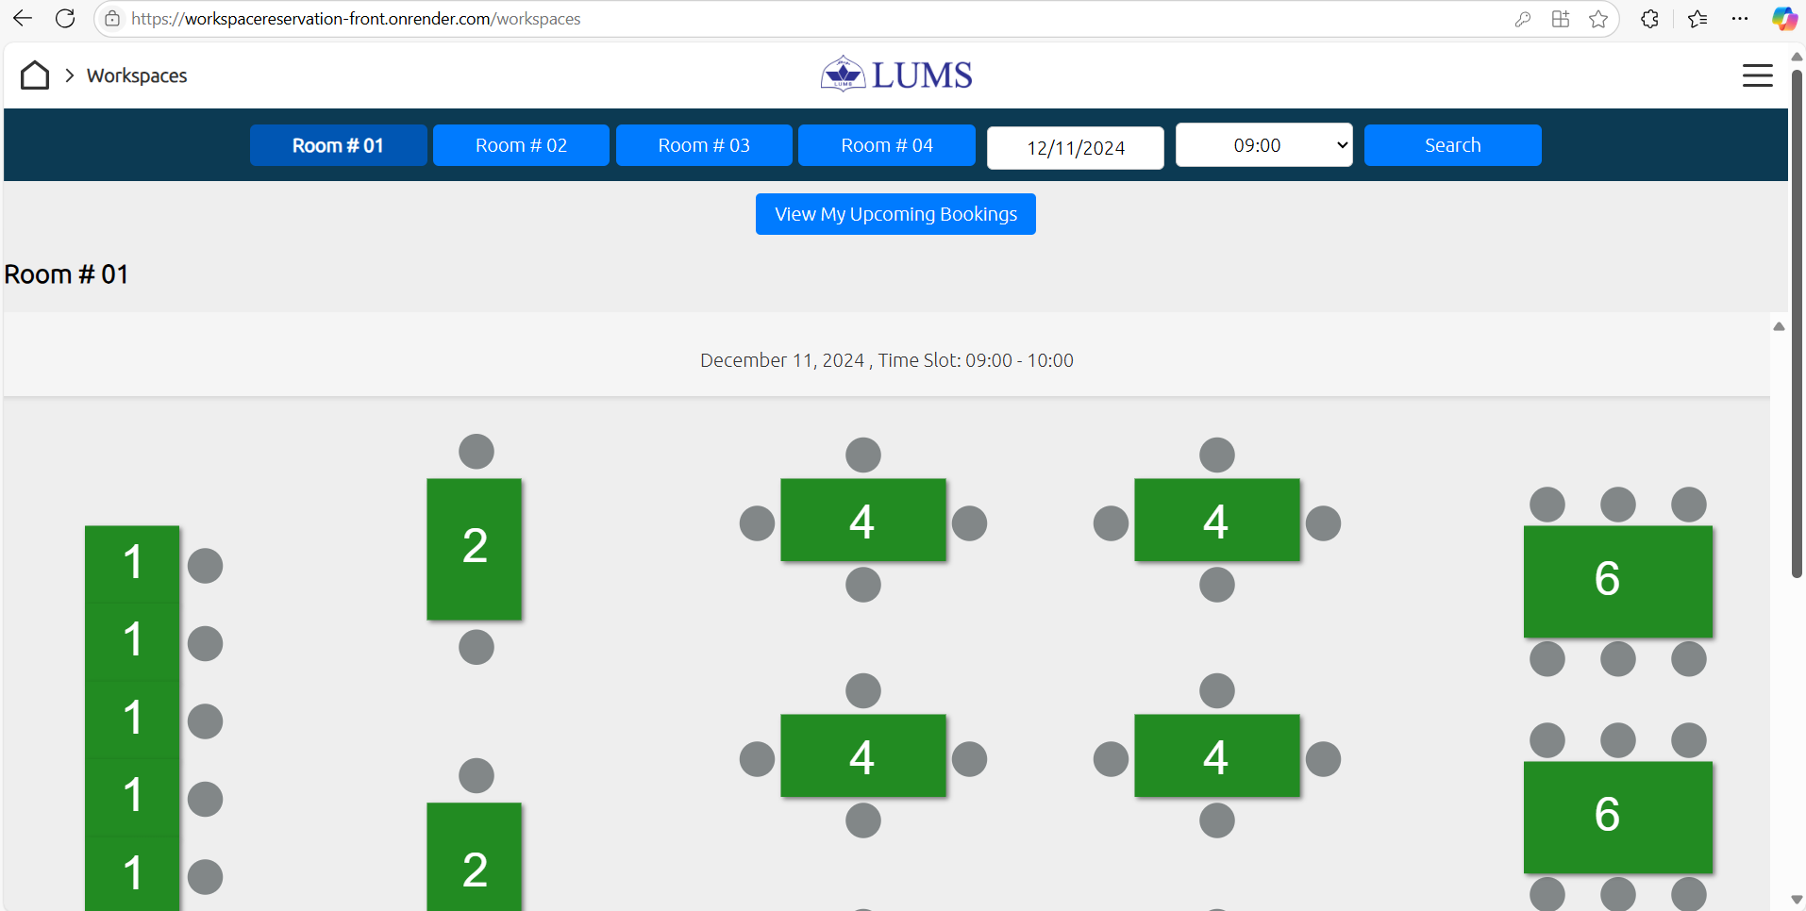
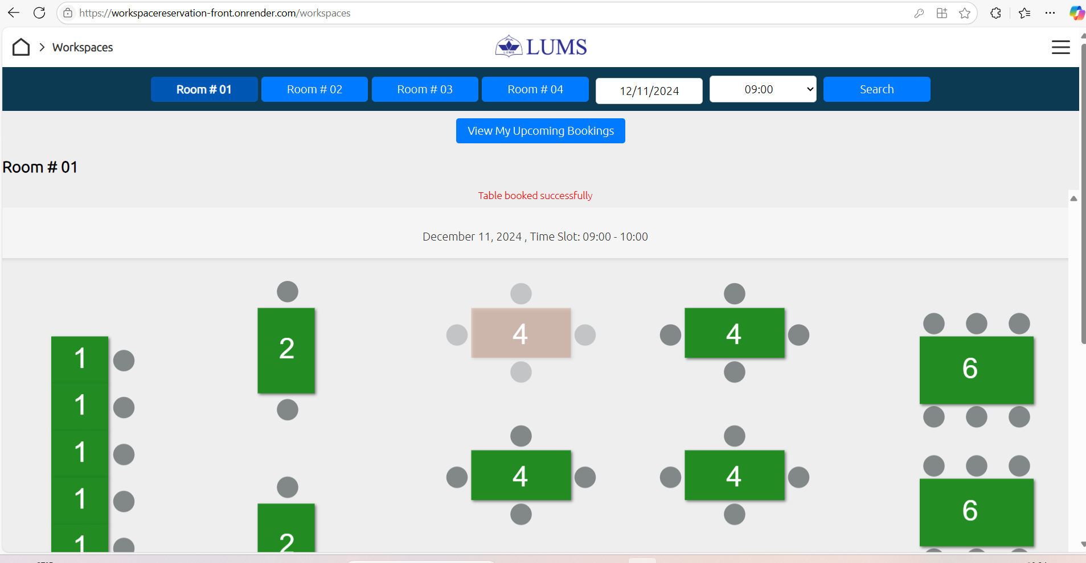

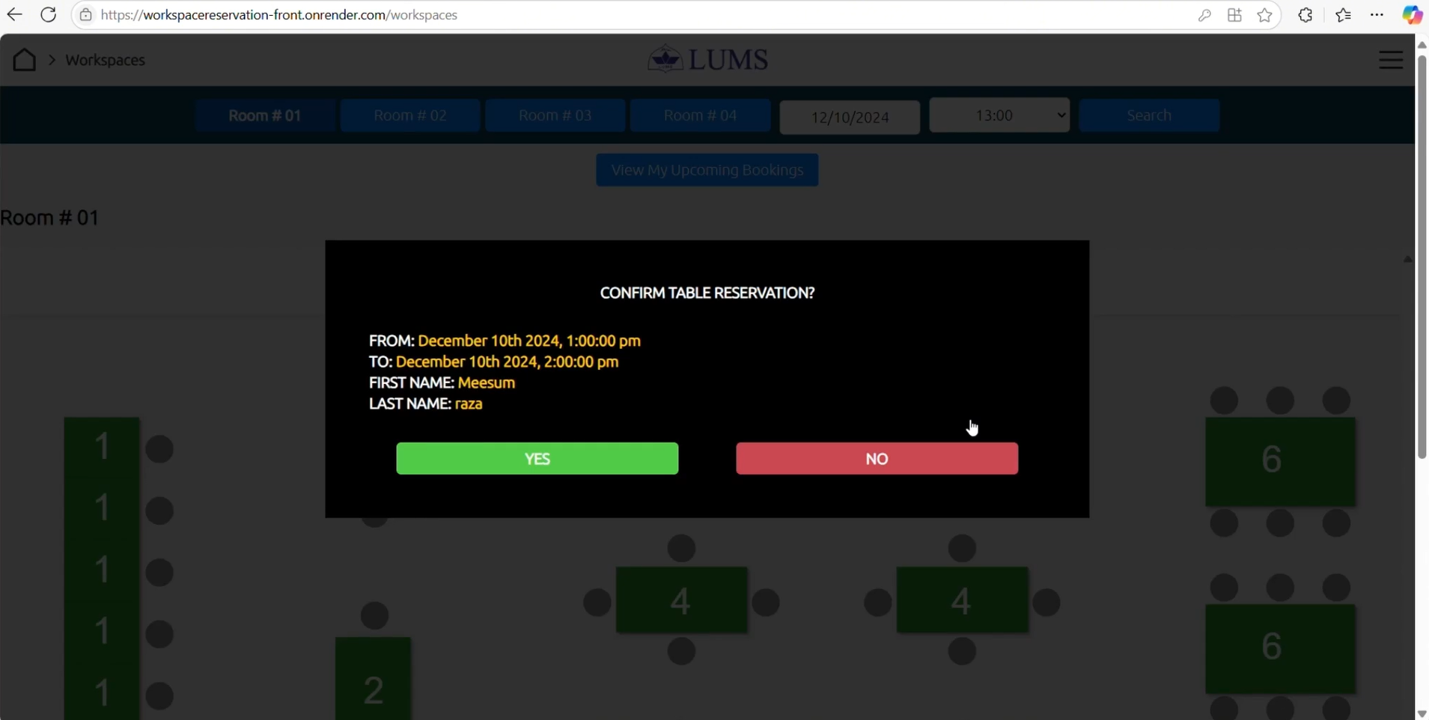

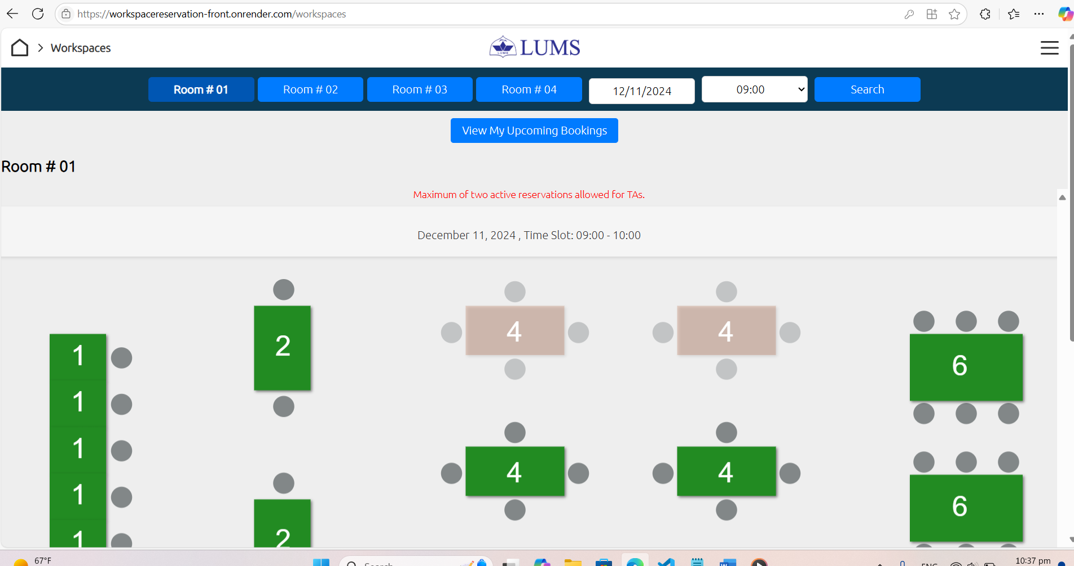

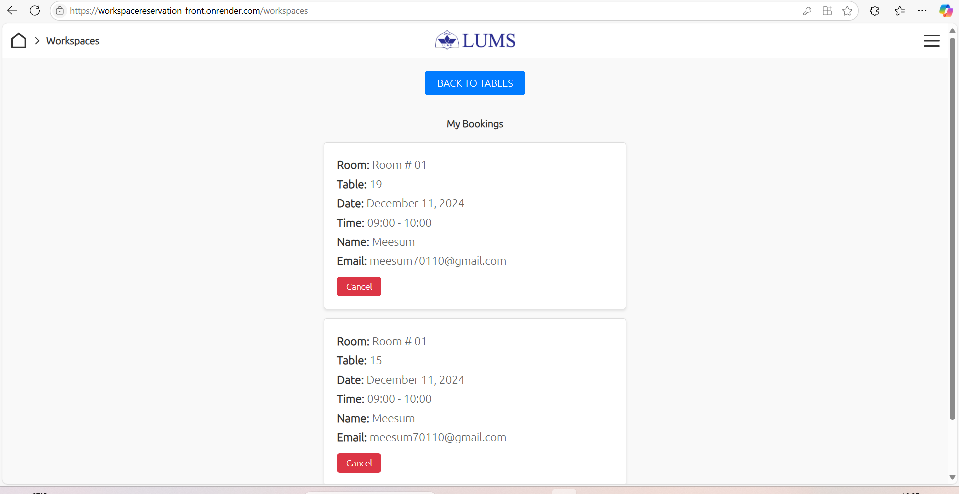

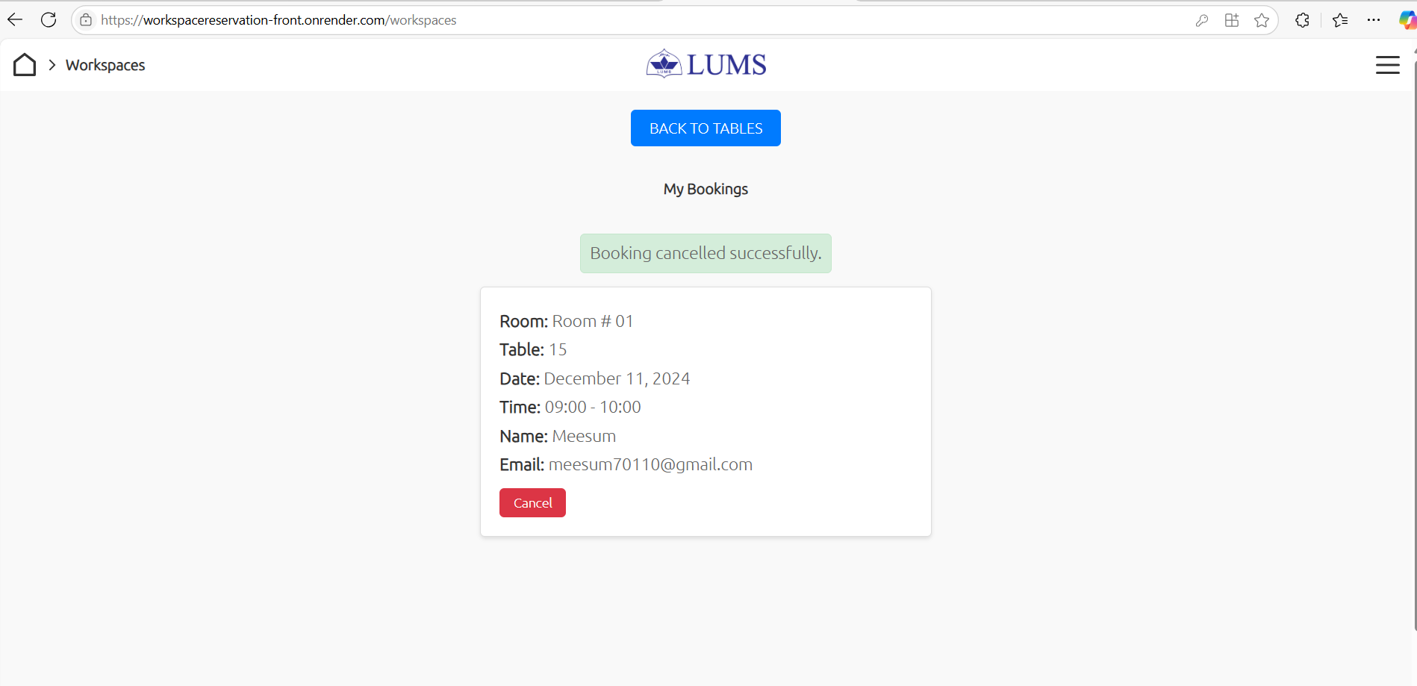

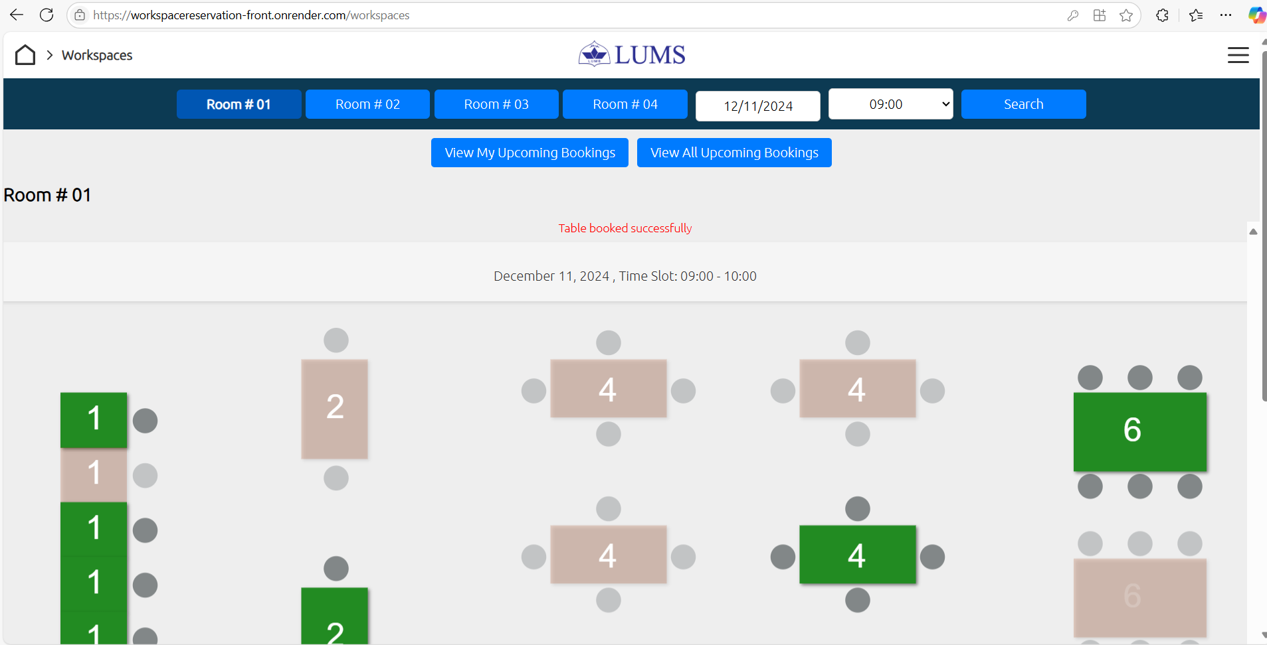

- FAQ Management:
  - Admins can add, or delete frequently asked questions (FAQs) visible to all users.
  - TAs can access FAQs to get quick answers regarding reservations, and cancellations.
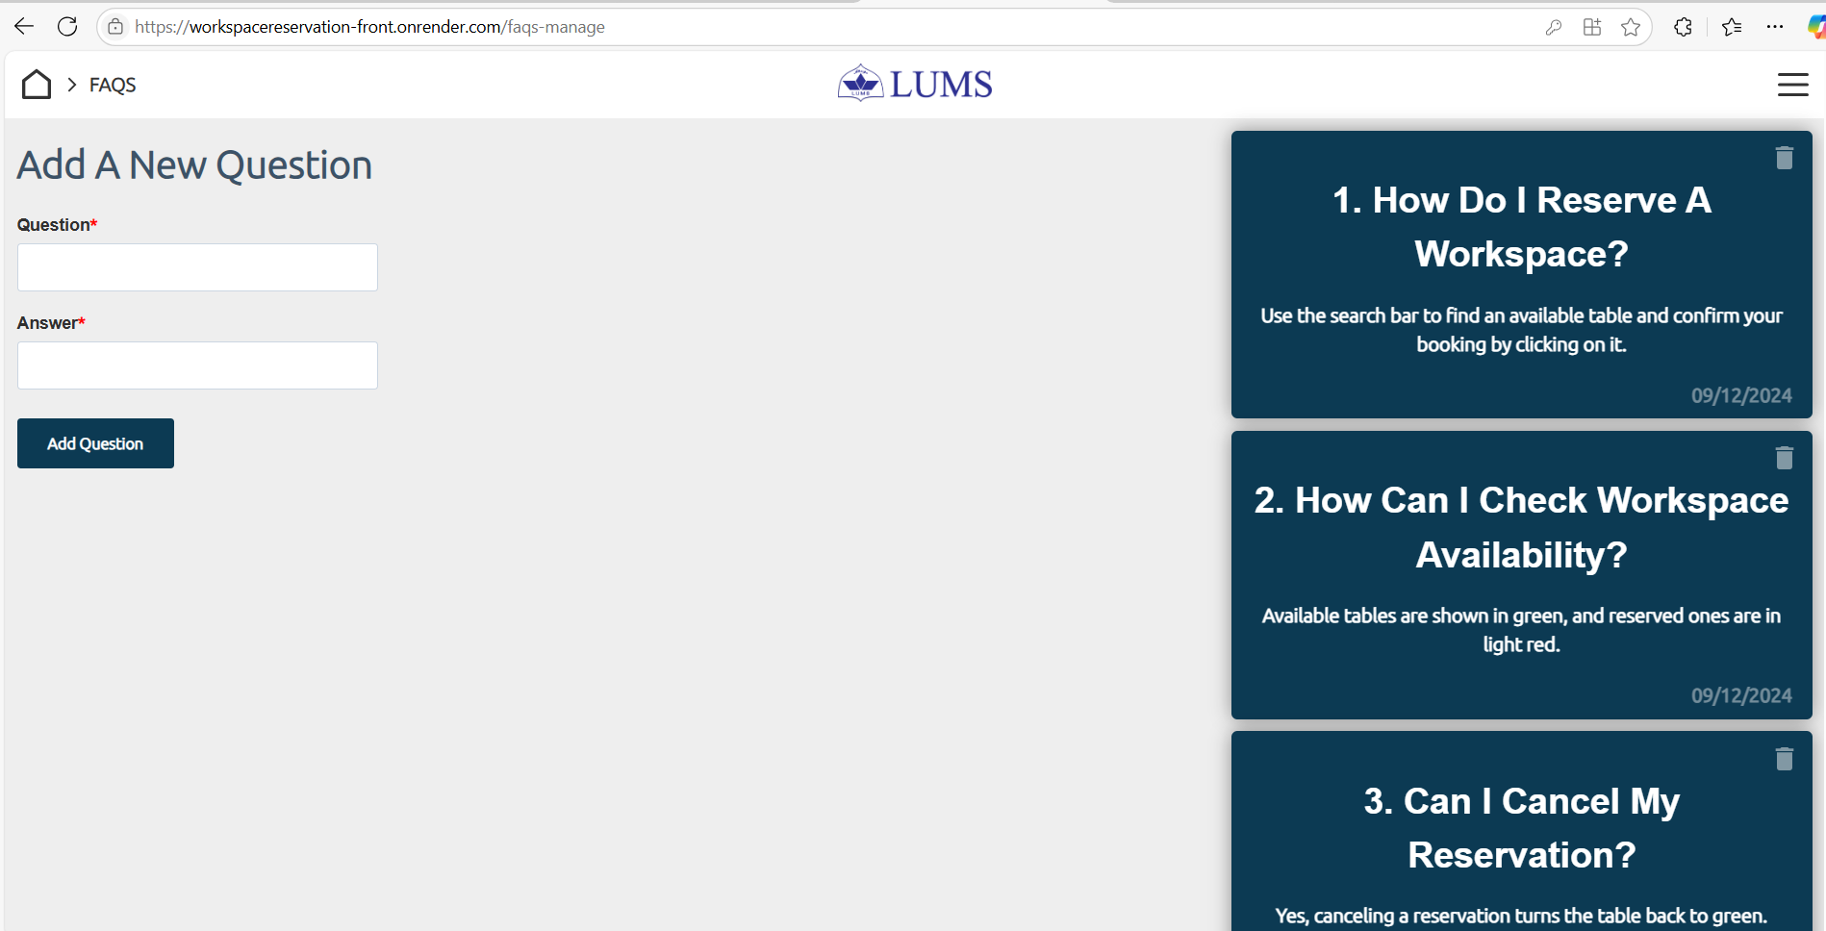

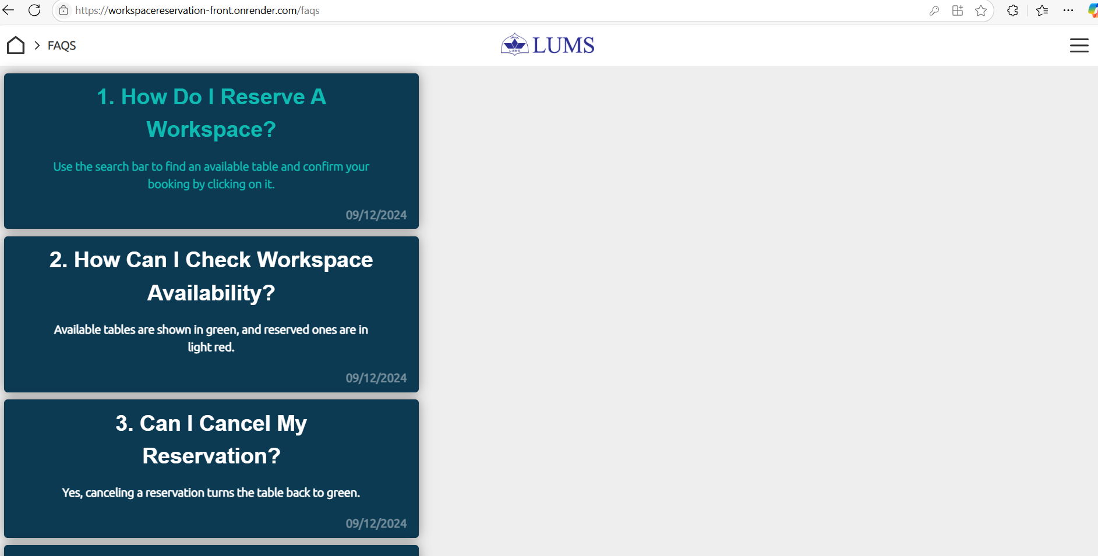

Project Security
This chapter focuses on the security aspects of the system, identifying potential threats, their consequences, and appropriate countermeasures to mitigate risks. It also highlights tools to ensure static and dynamic security scanning, aligned with the project's technologies.

Project Threats
The system's primary security threats include:
- Unauthorized access: Sensitive user data and booking information could be exposed without proper authentication controls.
- Data breaches: The API endpoints may be vulnerable to attacks like SQL injection or data scraping.
- Session hijacking: User sessions can be intercepted in the absence of secure protocols.
- Denial of Service (DoS) attacks: High server load due to malicious requests could make the system inaccessible.
- Cross-Site Scripting (XSS) and Cross-Site Request Forgery (CSRF): Manipulation of client-side scripts to compromise data or perform unauthorized actions.

Potential Losses
If the above threats are not mitigated, the potential losses include:
- Financial loss: Breaches can lead to financial penalties due to non-compliance with data protection laws.
- Business loss: Downtime or reputational damage can result in loss of clients and revenue.
- Legal actions: Exposure of sensitive data might lead to lawsuits or regulatory fines.
- Loss of user trust: Unauthorized access to bookings and user data can harm the credibility of the system.

Security Controls

To address these threats, the following controls should be implemented:
- Input validation: Ensure all user inputs are sanitized to prevent injection attacks (Protective).
- Audit logs: Track and log system activities for potential misuse (Detective).
- Secure API endpoints: Use HTTPS and implement token-based authentication (Protective, Responsive).
- Role-based access control (RBAC): Restrict actions based on user roles like TA, and coordinator (Protective).
- Multi-factor authentication (MFA): Add an extra layer of security for login (Protective).
- Rate limiting: Limit API requests to prevent DoS attacks (Protective, Responsive).
- Data encryption: Encrypt sensitive user data both at rest and in transit (Protective, Recovery).
Categorization of Controls
- Detective: Audit logs, API activity monitoring.
- Protective: Input validation, RBAC, MFA, secure protocols.
- Responsive: Rate limiting, session timeout.
- Recovery: Data backups, disaster recovery plans.

Static and Dynamic Security Scanning Tools
Considering the technologies used in the project (React, Node.js, MongoDB), the following tools can be selected:
- Static Analysis Tools:
  - ESLint Security Plugin: To identify vulnerabilities in JavaScript/React code.
  - SonarQube: For scanning code for bugs, vulnerabilities, and code smells.
- Dynamic Analysis Tools:
  - OWASP ZAP: For testing APIs and web applications against runtime vulnerabilities like XSS or CSRF.
  - Postman Security Testing: To check API endpoints for potential security risks.
These tools ensure proactive and comprehensive security scanning, helping maintain a secure and robust system.

Risk Management

Potential Risks and Mitigation Strategies
Sr. | Risk Description | Mitigation Strategy
 | Double bookings due to conflict resolution failure | Implementing rigorous testing and validating the conflict resolution module.
 | Scalability issues with increasing user traffic | Optimizing server performance using efficient APIs and upgrading to higher Render plans if needed.
 | Poor user experience due to unresponsive frontend | Conducting usability testing and optimizing React components for better performance.
 |  | Implementing robust authentication and role-based access control (RBAC).
  Unauthorized access to admin features
 | Integration issues with MongoDB Atlas | Testing database connections thoroughly and maintaining version compatibility between the application and MongoDB.
 |  | Performing unit testing and automated checks for the workspace booking logic.
  Errors in workspace availability status
 | Delay in project delivery due to unanticipated technical issues | Using Agile practices to adapt to issues quickly and prioritizing tasks effectively.
 | User credentials being exposed due to weak password storage | Implementing secure password hashing using bcrypt to ensure sensitive data is protected.
 | Email notifications failing due to NodeMailer limitations on Render free tier | Considering upgrading to Render's paid tier or integrating a reliable third-party email API service.
 | Inconsistent real-time updates for workspace availability | Using WebSockets for live updates and testing for high-concurrency scenarios to ensure consistency.

Testing and Evaluation

Testing and Evaluation Strategy
The project employed a comprehensive testing strategy incorporating manual black-box testing and automated testing using Jest to ensure the system's reliability, functionality, and usability.
Black-Box Testing:
Black-box testing focused on validating the system's behaviour without going into the internal code structure. Sample use cases tested include:
- Login Functionality:
  - Entering valid credentials (admin/user) to verify successful login.
  - Testing invalid inputs (e.g., incorrect email formats, wrong passwords).
  - Ensuring error messages like "Incorrect Email" and "Incorrect Password" are displayed.
  - Verifying the system prevents access to restricted pages unless logged in.
- Workspace Reservation:
  - Validating the reservation flow for TAs and Coordinators.
  - Restricting TAs to two active reservations.
  - Ensuring no double booking of tables and preventing booking of past times or dates outside the next 7 days.
Automated Testing with Jest:
Automated tests were implemented using Jest for faster and more consistent testing of critical functionalities, as shown in the screenshot.
- Features Tested:
  - Empty and invalid inputs in the login form.
  - Correct and incorrect login attempts for admin and employees.
  - Logout functionality for admin and employees.
  - Unauthorized access to restricted pages.
- Test Execution Results:
  - Each test case, such as logging in with incorrect credentials, was executed, and the time taken for each was recorded (e.g., "Empty email and password fields" passed in 263 ms).
Tools Used:
- Manual Testing: Conducted directly on the application, ensuring real-world scenarios were validated.
- Automated Testing: Jest was used to write and execute test cases programmatically. This ensured high coverage of edge cases while reducing manual effort.
The combined strategy ensured all functional requirements were met, errors were identified promptly, and the application performed as expected under various input conditions.

Deployment Guidelines

Accessing the Application on Render
You can access the live version of the Workspace Reservation web application hosted on Render by following
link: https://workspacereservation-front.onrender.com/
Testing Credentials: (Subject to changes)
Admin/Coordinator Login
- Email: 24100183@lums.edu.pk
- Password: Admin123.
User Login
1)
- Email: meesum70110@gmail.com
- Password: User123!
2)
- Email: meesum701110@gmail.com
- Password: User123!

You can contact 24100183@lums.edu.pk for updated testing credentials. Once logged in, you will have access to the respective admin or user/TA functionalities depending on the credentials you use. Explore the platform to manage or reserve workspaces, communicate in real time, and more!
Steps for Deployment in Production Environment (Render):
- Retrieve Code from GitHub:
Clone the repository from GitHub:
https://github.com/meesum70110/P12-UniversityWorkspaceReservationSystem.git
Use the main branch for deployment.
- Set Up Frontend Deployment:
  - On Render:
    - Create a new static site service.
    - Link the repository to the Render project and select the main branch.
    - Set the following configurations:
      - Root Directory: client
      - Build Command: npm install && npm run build
      - Publish Directory: client/build
      - Enable auto-deploy for automatic updates.
- Set Up Backend Deployment:
  - On Render:
    - Create a new web service for the backend.
    - Link the repository and select the main branch.
    - Set the following configurations:
      - Root Directory: server
      - Build Command: npm install
      - Start Command: npm start
    - Configure environment variables like MONGO_URI, JWT_SECRET, and other necessary keys.
    - Enable auto-deploy.
- Configure Environment Variables:
  - For both frontend and backend, set up necessary environment variables on Render to support production, such as:
    - Backend API URL for the frontend.
    - Database connection strings for the backend.
- Testing:
- Access the application via the production URLs.
- Verify functionalities such as user login, table reservation, and admin controls to ensure everything works as intended in production.

Conclusion

Summary
This project was developed step by step, starting from understanding user needs to creating a workspace reservation system using the MERN stack. The process included designing the system, building the front-end and back-end, and deploying it on Render. Working on this project helped me improve my coding skills, learn more about integrating APIs, and understand how to make an application ready for real-world use. It was a great learning experience in both development and deployment.

Challenges
There were several challenges during the project. One major issue was with the 'Add User' page, where the Admin or Coordinator can add new users. While the system works perfectly in a local environment and sends automatic emails to new users with their credentials, this feature did not work on the free version of Render due to its limitations. This required manual sharing of user credentials in the live system. Another challenge was creating a flexible design for workspace rooms to fit different layouts. On the non-technical side, it was hard to think from user point of view about how the workspaces map of the room should look like and then integrate it with backend.

Future
There is great potential to expand this system. For example, a new workspace is opening in H Block Johar Town, Lahore, near my house. I have shown this web app to them, and they are interested in using it for their business. Only a few changes, such as updating the workspace rooms map, will be needed, which can be done easily. Additionally, new features like adding more security options, better reports, or tools to analyze workspace usage can make the app even better for future clients.

Review checklist

Chapter/Section Name | Reviewer Name(s)
All the Chapters/Sections of this report | Syed Meesum Raza Naqvi

References

- Mern Stack development learning playlists that I referred to :
- https://youtube.com/playlist?list=PL4cUxeGkcC9iJ_KkrkBZWZRHVwnzLIoUE&si=OPSenRMCFBWDYy6g
- https://youtube.com/playlist?list=PL4cUxeGkcC9g8OhpOZxNdhXggFz2lOuCT&si=r2FCAN2TpMA6NuDq
- My own github repo: https://workspacereservation-front.onrender.com/
- Axios documentation: https://axios-http.com/
- MongoDB Atlas: https://www.mongodb.com/atlas/database
- React documentation: https://reactjs.org/docs/getting-started.html

